Education Trade-off Disadvantage

Notes!

The text of XO 13771
REDUCING REGULATION AND CONTROLLING REGULATORY COSTS
By the authority vested in me as President by the Constitution and the laws of the United States of America, including the Budget and Accounting Act of 1921, as amended (31 U.S.C. 1101 et seq.), section 1105 of title 31, United States Code, and section 301 of title 3, United States Code, it is hereby ordered as follows:
Section 1. Purpose. It is the policy of the executive branch to be prudent and financially responsible in the expenditure of funds, from both public and private sources. In addition to the management of the direct expenditure of taxpayer dollars through the budgeting process, it is essential to manage the costs associated with the governmental imposition of private expenditures required to comply with Federal regulations. Toward that end, it is important that for every one new regulation issued, at least two prior regulations be identified for elimination, and that the cost of planned regulations be prudently managed and controlled through a budgeting process.
Sec. 2. Regulatory Cap for Fiscal Year 2017. (a) Unless prohibited by law, whenever an executive department or agency (agency) publicly proposes for notice and comment or otherwise promulgates a new regulation, it shall identify at least two existing regulations to be repealed.
(b) For fiscal year 2017, which is in progress, the heads of all agencies are directed that the total incremental cost of all new regulations, including repealed regulations, to be finalized this year shall be no greater than zero, unless otherwise required by law or consistent with advice provided in writing by the Director of the Office of Management and Budget (Director).
(c) In furtherance of the requirement of subsection (a) of this section, any new incremental costs associated with new regulations shall, to the extent permitted by law, be offset by the elimination of existing costs associated with at least two prior regulations. Any agency eliminating existing costs associated with prior regulations under this subsection shall do so in accordance with the Administrative Procedure Act and other applicable law.
(d) The Director shall provide the heads of agencies with guidance on the implementation of this section. Such guidance shall address, among other things, processes for standardizing the measurement and estimation of regulatory costs; standards for determining what qualifies as new and offsetting regulations; standards for determining the costs of existing regulations that are considered for elimination; processes for accounting for costs in different fiscal years; methods to oversee the issuance of rules with costs offset by savings at different times or different agencies; and emergencies and other circumstances that might justify individual waivers of the requirements of this section. The Director shall consider phasing in and updating these requirements.
Sec. 3. Annual Regulatory Cost Submissions to the Office of Management and Budget. (a) Beginning with the Regulatory Plans (required under Executive Order 12866 of September 30, 1993, as amended, or any successor order) for fiscal year 2018, and for each fiscal year thereafter, the head of each agency shall identify, for each regulation that increases incremental cost, the offsetting regulations described in section 2(c) of this order, and provide the agency's best approximation of the total costs or savings associated with each new regulation or repealed regulation.
(b) Each regulation approved by the Director during the Presidential budget process shall be included in the Unified Regulatory Agenda required under Executive Order 12866, as amended, or any successor order.
(c) Unless otherwise required by law, no regulation shall be issued by an agency if it was not included on the most recent version or update of the published Unified Regulatory Agenda as required under Executive Order 12866, as amended, or any successor order, unless the issuance of such regulation was approved in advance in writing by the Director.
(d) During the Presidential budget process, the Director shall identify to agencies a total amount of incremental costs that will be allowed for each agency in issuing new regulations and repealing regulations for the next fiscal year. No regulations exceeding the agency's total incremental cost allowance will be permitted in that fiscal year, unless required by law or approved in writing by the Director. The total incremental cost allowance may allow an increase or require a reduction in total regulatory cost.
(e) The Director shall provide the heads of agencies with guidance on the implementation of the requirements in this section.
Sec. 4. Definition. For purposes of this order the term "regulation" or "rule" means an agency statement of general or particular applicability and future effect designed to implement, interpret, or prescribe law or policy or to describe the procedure or practice requirements of an agency, but does not include:
(a) regulations issued with respect to a military, national security, or foreign affairs function of the United States;
(b) regulations related to agency organization, management, or personnel; or
(c) any other category of regulations exempted by the Director.
Sec. 5. General Provisions. (a) Nothing in this order shall be construed to impair or otherwise affect:
(i) the authority granted by law to an executive department or agency, or the head thereof; or
(ii) the functions of the Director relating to budgetary, administrative, or legislative proposals.
(b) This order shall be implemented consistent with applicable law and subject to the availability of appropriations.
(c) This order is not intended to, and does not, create any right or benefit, substantive or procedural, enforceable at law or in equity by any party against the United States, its departments, agencies, or entities, its officers, employees, or agents, or any other person.
DONALD J. TRUMP
THE WHITE HOUSE,
January 30, 2017.

Explanation of the “Gainful Employment rule”
Mayotte 15 – Betsy Mayotte, Director of consumer outreach and compliance for American Student Assistance, regularly advises consumers on planning and paying for college. Mayotte received a B.S. in business communications from Bentley College, 2017, (“What the New Gainful Employment Rule Means for College Students: Programs affected by these regulations must meet and report minimum debt-to-income rates for their graduates”, July 8th, Available Online at https://www.usnews.com/education/blogs/student-loan-ranger/2015/07/08/what-the-new-gainful-employment-rule-means-for-college-students, Accessed 07-11-2017)
A new gainful employment rule has just gone into effect, and it could have a substantial impact on college students in a few years.
The gainful employment regulation requires vocational programs at for-profit higher education institutions and nondegree programs at community colleges to meet minimum thresholds with respect to the debt-to-income rates of their graduates. Programs that fail to meet these minimum requirements could lose access to all federal financial aid for a period, putting them at a higher risk of closing.
Proponents of the rule say it will weed out ​programs that saddle students with unmanageable education loan debt and lead to few quality job prospects. Critics of the rule argue that gainful employment will ultimately limit opportunity for students, especially those who turn to for-profit schools for flexible schedules as they juggle family, work and school.
[Get six answers for consumers about the new gainful employment rule.]
Gainful Employment's Rocky Road
In 2009, the Department of Education began a negotiated rule-making session with the goal of strengthening federal aid program regulations to better serve students and families. Gainful employment was rooted in the concept that a school should experience consequences for the lack of success of its alumni. Under the rule, nearly all programs at for-profit institutions and a few other institutions had to meet a minimum repayment and student debt-to-income ratio, and more information had to be disclosed to current and prospective students.​
The idea was to try and ensure that programs where students needed to take on debt to attend provided a robust enough education that these students could obtain employment with wages high enough to allow them to successfully repay that debt.
If the schools failed to meet these minimum criteria, access to federal student aid for those programs would be withdrawn. Many students cannot afford higher education without financial aid, so pulling a program's eligibility for federal aid programs is in most cases the death knell for that program or school.
The Association of Private Sector Colleges and Universities, the national association of for-profit schools, led the criticism of gainful employment and filed a lawsuit in 2012 claiming the rule was "arbitrary and capricious" and that the Department of Education had overstepped its authority in issuing it. The courts, for the most part, agreed.
In 2014, the Department of Education issued a new version of the gainful employment rule. This version maintained the disclosure, reporting and a version of the debt-to-income requirements, but did not require a minimum repayment rate. The association filed another suit later that year, but this time the courts sided with the Department of Education just in time for the July 1, 2015 effective date.
[Learn about more ways to pay for college.]
How Gainful Employment Works​
The rule measures a program's graduates' debt-to-income as follows:
• Programs whose graduates have annual loan payments less than 8 percent of total earnings or less than 20 percent of discretionary earnings are considered to have passed the requirements.
• Programs whose graduates have annual loan payments between 8 percent and 12 percent of total earnings or between 20 percent and 30 percent of discretionary earnings are considered to be "in the warning zone" and at risk of failing the requirements.
• Programs whose graduates have annual loan payments greater than 12 percent of total earnings and greater than 30 percent of discretionary earnings have failed the requirements.
• Programs that fail in two out of any three consecutive years or are in the zone for four consecutive years are no longer eligible for federal student aid for a minimum of three years.
There are a few more details that are important for consumers to be aware of. Gainful employment rules apply to most programs, certificates and degrees at for-profit institutions and most nondegree and certificate programs at all other schools. Only schools or programs that participate in the federal financial aid programs fall under the rule.
The rule only measures statistics for those students who actually complete the program. This is an important distinction, because students who do not complete their programs of study have the highest rate of default. Some proponents of gainful employment believe the rule does not go far enough, because if it only counts graduates, it leaves out a substantial portion of borrowers who would likely fail to meet the threshold.
[Check out three facts to know about for-profit colleges and student debt.]
What This Means for Consumers
Higher education consumers who currently attend or plan on attending vocational or nondegree programs should pay particular attention to how the program fares under the gainful employment rules. Schools at risk of failing the requirements must disclose this to both current and prospective students.
Students who attended a school that had to shut down because of gainful employment would be eligible for a discharge of their federal student loan debt However, that's not really an ideal situation, both for the student and the taxpayer who ultimately pays when federal debt is forgiven. A much better turn of events is for students to go into these types of programs with eyes wide open.
While there is still quite a bit of controversy around the rule, only time will tell if it is a truly effective way to help consumers determine the value of a program of higher education. One thing's for certain, though: More easily available and understandable public data to help families make the college choice is always a good thing.

More Explanation
https://www.usnews.com/education/blogs/student-loan-ranger/2014/11/19/6-answers-for-consumers-about-the-new-gainful-employment-rule

1NC/Overview

1NC – DA

The Education Department wants to cut the gainful employment rule – that’s key to preserving the gainful employment rule and minimizing student debt
Cowley and Cohen 17 – Stacy Cowley, Reporter who covers consumer finance for The New York Times, with occasional forays into small business and entrepreneurship, Patricia Cohen, Reporter who covers the national economy for The New York Times. Before joining The Times, Ms. Cohen worked at The Washington Post and Rolling Stone magazine, and did a stint working for a wire service in India. She started her journalism career at Newsday and New York Newsday as a member of the editorial board, and then political editor. She attended Cornell University and graduate school at Princeton University's Woodrow Wilson School, 2017, (“U.S. Halts New Rules Aimed at Abuses by For-Profit Colleges”, Available Online at https://www.nytimes.com/2017/06/14/business/student-loans-for-profit-schools-colleges.html?mcubz=0, Accessed 07-11-2017)
The Trump administration is formally reconsidering — and may dismantle — two new rules that were a cornerstone of the Obama administration's crackdown on predatory for-profit colleges.
The announcement by the Education Department on Wednesday freezes changes that would speed up and expand a system for erasing the federal loan debt of student borrowers who were cheated by colleges that acted fraudulently. It also throws into limbo what is known as the gainful employment mandate, which cuts off loans to colleges if their graduates do not earn enough money to pay off their student debt.
The move came just over two weeks before the new loan discharge rules were to take effect on July 1. The agency said it would form new rule- making committees to study both regulations and would hold off on implementing the discharge changes until the review was completed.
"Fraud, especially fraud committed by a school, is simply unacceptable," Education Secretary Betsy DeVos said in a statement. "Unfortunately, last year's rule-making effort missed an opportunity to get it right. The result is a muddled process that's unfair to students and schools, and puts taxpayers on the hook for significant costs."
The agency also took aim at the Obama administration's rules on gainful employment, criticizing them as "overly burdensome and confusing" for colleges.
Consumer advocates and some state officials quickly lashed out against the delay, calling it damaging and potentially illegal.
Maura Healey, the Massachusetts attorney general, called the delay a violation of federal law and a "betrayal of students and families across the country who are drowning in unaffordable debt." She said she would challenge it in court.
Critics including Senators Elizabeth Warren of Massachusetts and Patty Murray of Washington, both Democrats, argued that the department could not unilaterally suspend negotiated rules, which go through a process intended to ensure that the viewpoints of the public and those affected by the rules have been taken into account.
"I am extremely disappointed that Secretary DeVos has decided, once again, to side with special interests and predatory for-profit colleges instead of students and borrowers," Ms. Murray said in a statement.
The Obama administration pushed through sweeping regulatory changes after hundreds of for-profit colleges were accused of widespread fraud and subsequently collapsed, leaving their enrolled students with huge debts and no degrees. The failure of two mammoth chains, Corinthian Colleges and ITT Technical Institutes, capped years of complaints that some career-training colleges took advantage of veterans and other nontraditional students, using deceptive marketing and illegal recruitment practices.
Few higher-education institutions could survive without federal student aid, which includes billions of dollars in guaranteed loans, and the money kept streaming in despite warning signs at some colleges that included surging defaults, missed standards and numerous government investigations and lawsuits.
For-profit colleges have vehemently opposed the regulations, known as borrower defense, saying that the rules endanger their viability. They say the industry is being unfairly singled out.
Industry executives are particularly riled by automatic loan discharges for broad groups of defrauded students and by a new ban on forced- arbitration agreements, which prevent students from bringing lawsuits.
Under the rules frozen on Wednesday, education officials could, for example, take into account lawsuits, accrediting agency reports and graduates' job placement and wage records in deciding whether an institution remains eligible for federal student aid. The goal was to hold violators financially responsible for soured loans instead of dumping the burden on taxpayers.
In its announcement, the Education Department cited as reason for the delay a federal lawsuit filed on May 24 by an association of for-profit colleges in California that is seeking to block the rules.
On Tuesday, eight state attorneys general, including Ms. Healey, filed a motion to intervene in the California association's lawsuit in order to prevent the rules from being delayed.
Existing rules allow students to apply for a loan release if they attended a college that broke state laws. But that process, once used very rarely, has been overwhelmed with claims after a wave of failures by for-profit institutions. Some students have had applications pending for years.
Borrower advocates say the system came to a halt in the first few months of the Trump administration. The gears are turning again, according to the Education Department — but only for a fraction of those who are waiting.
In January, one week before President Trump took office, the Obama administration said 23,000 applicants had been notified that their claims had been approved. Nearly 7,000 of those claims have been discharged, and the rest will be soon, according to Elizabeth Hill, a department spokeswoman.
Correction: June 27, 2017
An article on June 15 about the Trump administration's review of Obama administration rules intended to crack down on predatory for-profit colleges referred incorrectly to part of an Education Department action involving such schools. The department said that it would reconsider provisions involving the "gainful employment" rule, which cuts off loans to colleges if graduates' earnings cannot meet their debt burden, not move immediately to halt the loans.

Any new rules require cuts --- regulatory budget is set at zero.
E&E Daily, 1/31/2017. “Analysts scratch their heads over Trump's 'pay-go' order,” http://www.eenews.net/eedaily/stories/1060049249.
President Trump yesterday signed an executive order that combines two regulatory reform measures that have seldom been paired and, until now, have mostly been theoretical concepts in the United States.
The executive order combines a regulatory "pay-go" approach with a regulatory budget, said Sofie Miller, senior policy analyst at the George Washington University Regulatory Studies Center.
"It's interesting," Miller said. "Typically we don't think about doing those types of reforms at once."
The "pay-go" or "one in, two out" section of the order, would require agencies to slash two rules for every new one. The regulatory budget would allow the president to cap regulations at a certain dollar amount per year.
Trump's regulatory budget for 2017 is zero dollars. If agencies want to issue new rules, they would be required to offset the costs by axing old ones (Greenwire, Jan. 30).

Student debt creates vicious cycles of poverty and unemployment
Thompson 16 – Maggie Thompson, Executive Director of Generation Progress. Campaign Manager for the Higher Ed Not Debt campaign. Founding member of Brass Tactics, a grassroots advocacy firm that engaged on key progressive priorities including bringing nontraditional voices to the climate-change fight, implementing the Affordable Care Act, and organizing for gun-violence-prevention legislation. Maggie served in the Obama administration at the White House Council on Environmental Quality as well as in the Office of the Director at U.S. Citizenship and Immigration Services. Maggie has also worked as a trainer with Wellstone Action since 2005, when she assisted in the development of the first Campus Camp Wellstone program. She worked for then-Sen. Barack Obama starting in 2007 during the Nevada primaries and became a regional field director in the 2008 Obama for America campaign in Saint Paul. Graduated with a degree in economics and classical archaeology from Macalester College, 2016, (“Why Student Loan Debt Harms Low-Income Students the Most”, May 2nd, Available Online at https://talkpoverty.org/2016/05/02/why-student-loan-debt-harms-low-income-students-the-most/, Accessed 07-11-2017)
Four years ago, student loan debt in America topped $1 trillion. Today, that number has swelled even further, with some 43 million Americans feeling the enduring gravity of $1.3 trillion in student loan debt.
While student debt may not intuitively register as something that plagues the poor, student debt delinquency and defaults are concentrated in low-income areas, even though lower-income borrowers also tend to have much smaller debts. Defaults and delinquencies among low-income Americans escalated following the Great Recession of 2008, a period when many states disinvested from public colleges and universities. The result was higher costs of college, which has led to larger loans.
Low-income students are often left at a dramatic academic disadvantage in the first place. For example, students who work full-time on top of college classes can’t cover the cost of tuition or living expenses, and working while in school can actually shrink the chance of graduating altogether. Moreover, these students are less likely to have access to career counseling or outside financial resources to help them pay for school, making the payoff negligible at best.
The inequity is so crushing that an alarming number of these students—predominantly students of color—are dropping out of school altogether. One-third of low-income student borrowers at public four-year schools drop out, a rate 10 percent higher than the rest of student borrowers overall.
When it comes to for-profit colleges, the story gets even worse. These institutions often target prospective students who are low-income while falsely assuring positive job and economic prospects upon graduating. Many students do end up dropping out, and even those who do graduate do not always receive a quality education that leaves them prepared for success—or with an income that matches up with their monthly loan payments. Their degrees too often cannot compete in the job market, leaving many of these students jobless.
This confluence of factors explains why borrowers who owe the least tend to be lower-income, and are the most likely to fall behind or default on their monthly payments. As the Mapping Student Debt project has found, people with more debt are less likely to default on their loan payments because they have the most access to wealth, whether through family money or financial assets or educational degrees. And it’s not hard to connect the dots. The biggest borrowers tend to be the biggest earners, so those who take out large loans to pay for graduate or professional school are less likely to default or fall behind because they’re in high-earning jobs. The Department of Education estimated that 7 percent of graduate borrowers default, versus 22 percent of those who only borrow for undergraduate studies. Default can actually lead to an increase in student loan debt because of late fees and interest, as well as a major decline in credit, ineligibility for additional student aid, and even wage garnishment at the request of the federal government.
Fortunately, there are solutions already in place that can help borrowers get out of default and back on their feet. For borrowers with federal loans, the Department of Education has a number of income-driven repayment programs (IDR) that cap a borrower’s monthly payment to as low as 10 percent of their discretionary income. Rather than being saddled with debt and an income that doesn’t realistically allow for repayment, borrowers can take advantage of programs such as PAYE, REPAYE, and Income-Based-Repayment to make their monthly loan payments proportional to their income. And some low-income borrowers might even qualify to pay nothing at all if they fall beneath certain income levels.
These plans won’t just help borrowers with high debt balances. IDR is especially helpful for borrowers with smaller balances because it reduces the monthly burden while keeping more money in pockets to cover expenses for food, housing, and other basic needs that borrowers must choose between in the face of overwhelming monthly payments.
Yet woefully few borrowers are aware of these plans that have the potential to make sure low-income borrowers aren’t paying more than they can afford. Fully 51 percent of student loan borrowers nationwide are eligible for these programs but only 15 percent are enrolled.
A dream of a higher education shouldn’t be a sentence to years—or an entire lifetime—of poverty. With federal IDR programs, the process of paying back any amount of student debt can be much less draining of an obligation, especially for our most vulnerable citizens. It’s on all of us to make sure those who can benefit the most from IDR are aware of it.

2NC – Turns Case

He’ll eventually cut the aff
Steinzor 17 – Rena Steinzor, Professor at the University of Maryland Carey Law School and former president of the Center for Progressive Reform,, 2017 (“The War on Regulation: Under Trump, it's open season on health, safety, labor, financial, and environmental measures—that protect people who voted for him”, April 17th, Available Online at http://prospect.org/article/war-regulation-0, Accessed 07-07-2017)
A cornerstone of Donald J. Trump’s presidential campaign was his declaration of war on regulation and the agencies that write it. He has promised repeatedly to get rid of 75 percent of rules now on the books. More recently, Steve Bannon, the chief policy guru in the Trump White House, defined the mission of the war more accurately as “deconstruction of the administrative state.”
Ten days after taking office, Trump issued an executive order to accomplish his regulatory pledge by requiring agencies to kill two rules for every new one they propose, and has held a press event to announce further attacks almost every day. Another major tool is the legislative veto of so-called “midnight” rules issued by the Obama administration in its last five months in office and the passage of “regulatory reform” legislation that would make future rulemaking very difficult. All of these changes are a dream come true for corporate lobbyists. The oil and gas industry alone spends $300 million annually to lobby Congress, and fields three lobbyists per member.
Legislative vetoes are permitted under a 1996 law, the Congressional Review Act, enacted by the Gingrich Congress, aimed at thwarting President Bill Clinton’s efforts to regulate prior to a presidential election that Republicans hoped to win. The first midnight rules to fall in the Trump era included a Securities and Exchange Commission requirement that oil and gas companies disclose how much they paid foreign governments for drilling rights—a provision of the Dodd-Frank bill enacted to detect illegal bribery; a Department of Interior prohibition on coal companies dumping mountaintop removal debris in streams; and a requirement that the Social Security Administration support gun control enforcement by sending to the attorney general the names of severely disturbed people receiving disability benefits.
As this article goes to press, two more repeals await Trump’s signature: a rule that requires states to assess individual school performance and report those results to parents, and a rule developed by the Bureau of Land Management to give the public more say in whether to allow drilling, mining, and logging on 250 million acres of public land. Oil and gas interests, coal and other mining companies, and the gun lobby led the scrum, but electric utilities, federal contractors, bankers, payday lenders, and the chemical industry were not far behind.

Uniqueness

2NC UX – AT: DeVos Will Regulate

Devoss devolved education to the states
Lobosco 17 – Katie Lobosco, Columnist at the Central News Network, 2017, (“Betsy DeVos freezes Obama-era rules meant to protect student borrowers”, June 14th, Available Online at http://money.cnn.com/2017/06/14/pf/college/betsy-devos-student-borrower-protections/index.html, Accessed 07-11-2017)
The Department of Education will halt two Obama-era rules that would have protected student borrowers and held for-profit colleges accountable.
The rules were set to take effect on July 1. But instead, the department said Wednesday that it will create committees to review and improve the rules.
"It's time to take a step back and make sure these rules achieve their purpose: helping harmed students," Education Secretary DeVos said in a statement.
Related: What is (and isn't) in the budget for student loan borrowers
One of the rules in question required for-profit colleges and certificate programs at non-profit colleges to show that the education their students receive leads to "gainful employment." If they fail to meet that standard, the schools' federal aid would be withheld.
The Borrower Defense to Repayment rule clarified how student borrowers who were defrauded or misled by their college can apply for loan forgiveness. It was created after the government received an unprecedented number of claims following the collapse of Corinthian Colleges.
This rule also created a fast-track way for students to apply for forgiveness in the event their college closed. That part of the rule was implemented early to help Corinthian students, specifically.
The department said it would keep its debt forgiveness promise to the 16,000 borrowers who currently have claims being processed.
"Fraud, especially fraud committed by a school, is simply unacceptable. Unfortunately, last year's rule-making effort missed an opportunity to get it right," DeVos said.
Related: Betsy DeVos tells Congress student debt is 'of grave concern'
Critics argue that these rules are too burdensome for colleges. A group representing many for-profit colleges in California has sued the Department of Education seeking to block the borrower defense rule from going into effect.
The plaintiff, The California Association of Private Postsecondary Schools, said the rule "threatens the existence" of many of its member institutions, according to the lawsuit.
A group of nine Attorneys General, all Democrats, filed a motion this week to intervene in the lawsuit. And some Democratic senators have urged DeVos to keep the rules in place.
"Delaying this important pathway to debt relief would harm thousands of students, many with crushing levels of student loan debt and few meaningful job prospects," read a letter signed by Senators Elizabeth Warren, Patty Murray, Sherrod Brown and Dick Durbin.
The Department of Education said it will hold hearings on the rules in July.

DeVoss has not enacted regulations and delegated power to the states
Fox News 17 – Fox News, Radio and News Station, 2017 (“DeVos: 'School choice' will not be mandated by Washington”, May 23rd, Available Online at http://www.foxnews.com/politics/2017/05/23/devos-school-choice-will-not-be-mandated-by-washington.html, Accessed 07-10-2017)
Betsy DeVos, the U.S. education secretary, said Monday that although President Trump’s administration will put forward plans of a historic expansion of school choice, the ultimate decision will be left with the states, not Washington.
Politico reported that DeVos made the comments during a speech at an Indianapolis summit hosted by the American Federation for Children.
“When it comes to education, no solution, not even ones we like, should be dictated or run from Washington, D.C.,” she said.
DeVos told the Senate Health, Education and Pensions Committee in January that she would be "a strong advocate for great public schools,” but added that "if a school is troubled, or unsafe, or not a good fit for a child ... we should support a parent's right to enroll their child in a high-quality alternative."
Trump's nomination of DeVos to lead the Department of Education was harshly criticized by the teachers’ unions, who have claimed that DeVos wants to undermine the public education system, which provides instruction to more than 90 percent of the country's students.
Vince M. Bertram, the author of “One Nation Under Taught: Solving America’s Science, Technology, Engineering and Math Crisis, wrote that DeVos’ most important task will be to cast a vision for what education can be for our next generation to meet the demands of a global economy.
Politico reported that DeVos did not go into detail about what steps the Trump administration will take to implement its school-choice goals. She said states that opt out would be making a “terrible mistake” and will be “hurting the children and families who can least afford it.”

2NC UX – AT: No Political Will

Freedom Caucus and Trade Associations support cuts
Steinzor 17 – Rena Steinzor, Professor at the University of Maryland Carey Law School and former president of the Center for Progressive Reform,, 2017 (“The War on Regulation: Under Trump, it's open season on health, safety, labor, financial, and environmental measures—that protect people who voted for him”, April 17th, Available Online at http://prospect.org/article/war-regulation-0, Accessed 07-07-2017)
Two powerful categories of interest groups have combined forces to support deregulation. The first is led by the Freedom Caucus, the loose organization of House Tea Party members, which fiercely opposes the regulatory state. Dismantling rulemaking represents low-hanging fruit that, in the immortal words of Grover Norquist, president of Americans for Tax Reform, reduces government “to the size where I can … drown it in the bathtub.” The caucus sent Trump a list of 228 rules in need of destruction. The list identified 73 separate rules addressing climate change.
The second category of participants is the long list of trade associations, exemplified by the Chamber of Commerce and the National Association of Manufacturers, that represent industries subject to proposed or existing rules. As a whole, this category of participants is both more eclectic and more pragmatic, without any unifying agenda other than saving money by blocking regulation. Bridging the gap between the two categories are conservative think tanks such as the Heritage Foundation and the Competitive Enterprise Institute.

2NC UX – AT: Thumpers

Trump won’t regulate in fear of business retaliation
Malloy 17 – Daniel Malloy, Reporter and Columnist at the Ozy Newspaper, 2017 (“Where Trump is Crushing it: No New Red Tape”, July 7th, Available Online at http://www.ozy.com/politics-and-power/where-trump-is-crushing-it-no-new-red-tape/79058, Accessed 07-10-2017
Thrashing big government has long been a Republican credo, and crusading against government regulation was one area where Donald Trump did speak like a traditional member of his party on his rollicking road to the White House. In office, much has been made of Trump’s troubles with federal investigators, but when it comes to cutting red tape, Trump is getting things done in a striking way — in part by … not doing much. Over the administration’s first four months:
Trump’s cabinet agencies are on pace to impose less than 1 percent of the new regulatory costs of previous presidents.
The number comes from an analysis by the American Action Forum, a conservative think tank, crunching data from the federal Office of Information and Regulatory Affairs going back to 1994. In January, Trump signed an order dictating that, for every new regulation made, two must be repealed. If you include independent agencies outside of his direct control, Trump’s new regulations in his first months would have a $4 billion annual cost on business. But when you include only Trump’s cabinet agencies, that number plummets to $33 million — compared to $26 billion per year from 2005 to 2016.
Working with Congress, Trump also has repealed a record number of Obama rules via the seldom-used Congressional Review Act — from environmental protections for streams to workplace-safety restrictions for government contractors. But the administration also has acted on its own, through the emergency “interim final rule” process, such as blocking the requirement for chain restaurant menus to list calorie counts just days before it was to go into effect. “From the conservative perspective, it is a needed pause in the historic regulatory growth of the past administration,” says Sam Batkins, director of regulatory policy at the American Action Forum.
Trump’s critics say the focus on costs alone ignores the benefits of government rules. Restrictions on power plant emissions, for example, save money on asthma treatments for surrounding communities, studies by the Obama administration’s Environmental Protection Agency projected. A closer eye on banks could help prevent another financial crisis. And then there’s the fact that businesses often crave regulation, for the sake of providing consistent guidelines. The commercial drone industry is practically begging for clear rules. In this case, the regulatory slowdown could be coming in part because the Trump administration has been slower than its predecessors to fill political appointee jobs across the agencies.
Sam Berger, senior policy adviser at the liberal Center for American Progress think tank, says the regulatory halt signals that “Trump is putting corporate profits over people.” But the lack of total rules, whether friendly or unfriendly to business, means “it’s hard to separate out how much of that is incompetence and how much of that is purposeful.”
While Batkins says the deregulation push “could save billions of dollars and could contribute somewhat to [economic] growth,” the exact impact is near impossible to quantify. And there are outside factors that could force a change of pace. Laws and court rulings often set mandatory regulation deadlines, and many environmental regulations in recent years have been court-ordered. Activist group Public Citizen is challenging the “two-for-one” order as unconstitutional. Trump’s power to regulate as much or as little as he likes rests, in the end, with the judiciary.

Trump has done nothing politically significant
Keith 17 – Tamara Keith is a NPR White House Correspondent and co-host of the NPR Politics Podcast. Bachelor's degree in Philosophy from the University of California, Berkeley, and a master's degree at the UCB Graduate School of Journalism, 2017 (“Despite Claims To Contrary, Trump Has Signed No Major Laws 5 Months In”, June 23rd, Available Online at http://www.npr.org/2017/06/23/533840991/despite-claims-to-contrary-trump-has-signed-no-major-laws-5-months-in, Accessed 07-07-2017)
President Trump kept one of his campaign promises, signing a bill Friday to make it easier for the secretary of veterans affairs to fire and discipline employees. It came in response to the 2014 VA scandal in which employees covered up long wait times while collecting bonuses.
The bill, which passed earlier this month with strong bipartisan support, also gives the secretary authority to revoke bonuses and protects whistleblowers who report wrongdoing.
"What happened was a national disgrace and yet some of the employees involved in these scandals remained on the payrolls," Trump said just before signing the bill. "Outdated laws kept the government from holding those who failed our veterans accountable. Today we are finally changing those laws."
The Department of Veterans Affairs Accountability and Whistleblower Protection Act of 2017 marks Trump's 40th law signed.
Sounds like a lot.
And in recent days, Trump has boasted about all the legislation he has signed.
"We passed and signed 38 pieces of legislation, which nobody likes to talk about," Trump said June 13 before a lunch with lawmakers. "I think probably seldom has any president and administration done more or had more success so early on, including a record number of resolutions to eliminate job-killing regulations."
And he tweeted the same message on Friday morning.
A White House spokesperson confirmed to NPR that at the time of Trump's tweet, the number was actually 39 — not 38.
Measuring laws passed by counting rather than by significance is pretty meaningless. More on that in a bit. Among modern Oval Office occupants, Presidents Jimmy Carter (52), George H.W. Bush (41) and Bill Clinton (41) had all signed more bills into law than Trump has by this point in their presidencies.
So, what has Trump accomplished with Congress so far? Nothing that political scientists would categorize as major pieces of legislation. We looked at this question as Trump hit his 100 days mark. This story contains more detail on legislation he signed in the early part of his presidency.
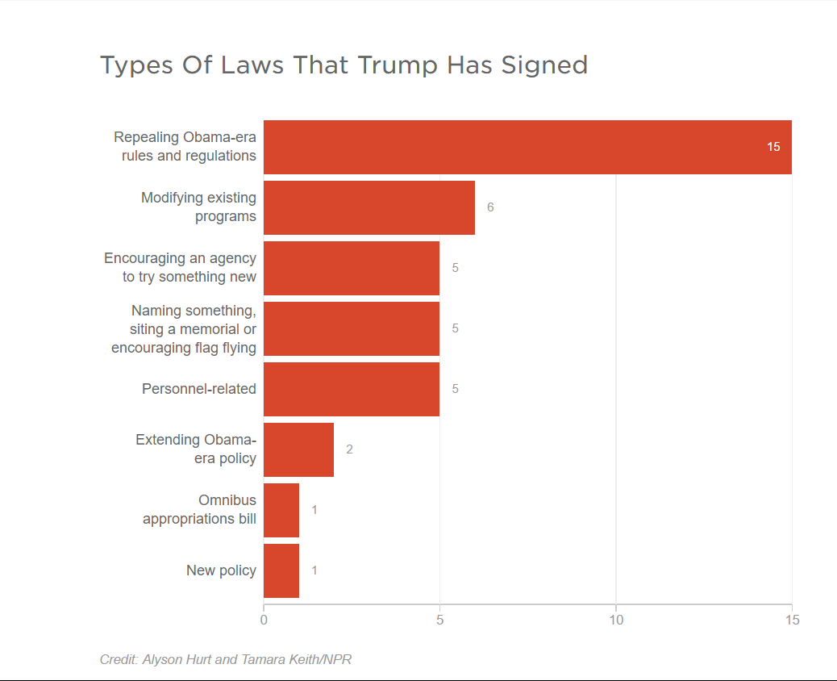

No thumpers – There have been exactly zero new regulations
Vinik 17 – Danny Vinik, journalist and writer for Politico, 2017, (“Under Trump, regulation slows to a crawl”, June 7th, Available Online at http://www.politico.com/agenda/story/2017/06/07/trump-regulation-slowdown-000446, Accessed 07-07-2017)
The near-total freeze in regulations is likely to keep GOP supporters happy, converting on a long-held conservative dream of a government that stays out of the way. “It’s a reason to celebrate,” said Stephen Moore, a fellow at the Heritage Foundation who informally advised Trump during his campaign.
But rulemaking is the key way a White House shapes policy, and for an administration that has struggled to populate federal agencies and get laws passed through Congress, the rulemaking gap denies the administration its biggest chance to make an impact on how America runs. The slowdown has begun to concern some business groups, who worry that key regulations simply aren’t being issued as expected—and liberals warn it could leave the government playing catch-up with major changes.
“It’s slowed to a crawl, and I’m sure for some folks, that’s a demonstration that the administration is putting their money where their mouth is,” said Amit Narang, a regulatory expert at Public Citizen, a watchdog group. “But for us, this is really alarming.”
Asked about the slow pace of rulemaking, the Trump administration was alternatively defensive about the process and eager to portray it as a promise kept. An official at the Office of Management and Budget said in a statement that “simply counting regulations is a simplistic approach,” noting that during the Bush administration—whose officials were not exactly regulatory zealots—OIRA reviewed more significant rules than under Obama. But the official then argued that “this administration as a whole agrees with hard-working Americans: unnecessarily burdensome regulations choke economic growth.”
In that sense, the inaction could be counted as one of the successes of the Trump agenda. Chief strategist Steve Bannon said at a conservative conference in February that Trump’s goal was the "deconstruction of the administrative state,” applying the brakes to a regulatory system that had grown too big and unruly and is a drag on the economy. Trump imposed a regulatory freeze on his first day in office—a typical move for new presidents—and then signed an executive order clamping down on regulation, requiring an agency to identify two regulations to eliminate for each new one it wants to issue. In addition, under the order, the economic costs of the two so-called deregulatory actions must equal or exceed the economic cost of the new regulation.
The “two-for-one” order, signed January 30, applies only to “significant” regulations with an economic impact exceeding $100 million or meeting other specified criteria, and it may be working in a counterintuitive way: Although it was touted as a way to roll back old rules, its main impact appears to be simply erecting obstacles to new regulations. So far, the Trump administration has issued exactly zero rules that have had to comply with the “two-for-one” policy. “You can certainly make the case that it’s had a pretty big effect on the regulatory output,” said Sam Batkins, a regulatory expert at the American Action Forum.

2NC UX – AT: “Costs” Calculation

“benefits?” LOL nope
Krupnick 17 – Alan J. Krupnick, Senior Fellow and Co-Director at the Resources for the Future for Energy and Climate Economics, 2017 (“Doubling Down on Trump’s Two-for-One Regulatory Reform”, February 7th, Available Online at http://www.rff.org/blog/2017/doubling-down-trump-s-two-one-regulatory-reform, Accessed 07-07-2017)
The unreasonableness of this approach comes from the realization that the analysis needed to eliminate a regulation is every bit as complex as the analysis needed for a new regulation. Thus, to promulgate a new regulation actually requires three new analyses instead of one—two for the regulations on the chopping block and one for the new one. The result, without waivers or exceptions, will likely be serious procedural roadblocks and delays in regulatory activity.
Fortunately, waivers and exceptions do exist for statutory and judicial mandates, but they are very limited. If an agency is required to issue a regulation because of “imminent statutory or judicial deadline” it may avoid the two-for-one offset temporarily. Here the definition of imminent would be important, as issuing major rules—such as re-promulgating the National Ambient Air Quality Standards every five years under the Clean Air Act or regulating 10 toxic substances over the next three years under the 2016 updates to the Toxic Substances Control Act—requires several years of effort. But, even for these rules, the agency would be required to eventually find offsetting regulations to eliminate. With an agency issuing only a few exceedingly costly regulations a year, and all with statutory mandates, where will the offset come from without violating the statutory mandates underlying the major regulations slated for elimination? More generally, because regulations are issued in the first place to meet statutory (and by extension, regulatory) goals, how can their elimination not lead to those goals being missed or compromised? Does the Trump administration really believe that there are significant regulations on the books that do not aid in meeting statutory goals—and that such regulations are numerous enough that they can offset necessary new rulemaking?
Waivers can also be offered on other, still unspecified grounds. And regulations issued “with respect to military, national security, and foreign affairs functions” are exempt. And, as usual, independent agencies (those agencies that don’t submit regulations to OMB) are exempt.
The most important unanswered question raised by the executive order is whether benefits count. On this the OMB memorandum is unequivocal: No. Even the cost savings to a company that, say, buys energy efficient lighting as a result of a rule do not count against the cost of the lighting fixtures because “In most circumstances, such effects would not be counted as offsets to costs according to [the Office of Information and Regulatory Affair’s] reporting conventions for benefit-cost analysis.” In other words, the cost savings don’t count because OMB classifies them as benefits, and counting benefits is not part of this new regulatory process. It then goes almost without saying that the main rationale for many of these rules in the first place—often benefits to health and the environment—is to be ignored in assessing which regulations are to be eliminated.
Here is where all logic is firmly left behind. As I noted earlier:
Counting only costs is like having scissors with only one blade: pretty useless for accurate cutting, but great for gouging. … Since costs and benefits were used to justify the regulation in the first place, how can benefits be ignored now? Indeed, the purely efficiency-driven economists’ prescription would be to count social costs and benefits—net benefits—and the policy prescription would be to maximize net benefits. This would mean eliminating rules with net costs and passing rules with net benefits, with no limit on the size of the costs or net benefits.
The illogic of ignoring benefits comes most clearly from the memorandum’s statement that the purpose of the executive order is to eliminate ineffective, unnecessary, and outdated regulations. How is one to know which regulations are ineffective and unnecessary without considering the regulations’ benefits? Clearly one cannot. And yet, the memorandum is careful to say that statutory goals must continue to be met—“agencies must confirm that they will continue to achieve their regulatory objectives (e.g., health and environmental protection).” By the same token, how can one know whether or not this is the case without considering the benefits (i.e., health and environmental protections)?
The fundamental problems with Trump’s two-for-one executive order and the OMB memorandum are that regulations can be eliminated that have larger benefits to society than costs, and that new regulations face three times the analytical hurdles they would normally face. In the process, it is hard to see how statutory goals would not be compromised. Thus the order is counterproductive, unreasonable, and illogical. Comments on the memorandum must be submitted to OMB by this Friday, February 10.

2NC UX – AT: XO Rollback

It applies at least past 2018
Austin 17 – Sidley Austin, Head Legal Attorney of the Sidley Austin Lawyer Firm, 2017 (“Challenge to two-for-one executive order may affect environmental regulations”, March 13th, Available Online at http://www.lexology.com/library/detail.aspx?g=59938d6b-26a5-448e-8cd3-7a74026898d9, Accessed 07-07-2017)
How long will the order remain in effect?
Section 2 of the order, establishing a requirement to identify two regulations to be repealed for every new significant regulation promulgated, explicitly applies only to fiscal year 2017, which ends on September 30 2017. However, Sections 3(a) and 3(d) establish a regulatory budgeting programme that requires the Office of Management and Budget to allocate to agencies a total amount of incremental costs that will be allowed for issuing regulations in fiscal year 2018 and beyond. The Office of Management and Budget will issue a new guidance memorandum to agencies for those years. It is not yet clear whether the 'two-for-one' repeal requirements will continue to apply in later fiscal years.

Link

2NC Link – “Two-for-One”

Any reg requires two to be cut
Washington Post, 1/30/2017. “Trump wants to scrap two regulations for each new one adopted,” https://www.washingtonpost.com/news/energy-environment/wp/2017/01/30/trump-wants-to-cut-two-regulations-on-businesses-for-every-new-one-imposed/.
President Trump signed an order Monday aimed at cutting regulations on businesses, saying that agencies should eliminate at least two regulations for each new one.
The White House later released the text of the order, which added that the cost of any new regulation should be offset by eliminating regulations with the same costs to businesses. It excluded regulations regarding the military.
The impact of the order was difficult to judge based on the president’s remarks. It could be difficult to implement under current law and would concentrate greater power in the Office of Management and Budget, which already reviews federal regulations.
Moreover, any effort to scrap a regulation triggers its own process, complete with draft rules, comment periods, and regulation rewriting. That process can be subject to litigation. At the least, Trump’s proposal would add a new time-consuming requirement for any new congressional legislation or agency regulation on topics as varied as banking, health care, environment, labor conditions and more.

Regulatory budget means any new regulation forces tradeoffs.
E&E Daily, 1/31/2017. “Analysts scratch their heads over Trump's 'pay-go' order,” http://www.eenews.net/eedaily/stories/1060049249.
Jim Tozzi, a longtime government employee who helped develop the regulatory budget idea during the Carter administration, said people are so focused on the "one in, two out" aspect of the order that they're missing the point.
"A regulatory budget sets a limit on the total cost of regulation that the EPA can impose," he said. "That's a huge change in the way the government operates."
"The bottom line is we've been proposing this for 37 years," he said.
Administrations have in fact flirted with the idea of a regulatory budget for years but have yet to try it out.
Tozzi said that going forward, OMB employees will set not just the fiscal budget but also a regulatory one. However, Congress approves the fiscal budget. Under the executive order, the regulatory budget would be set by the executive branch.

Trump signs xo that requires to regulations to be rescinded for every new one
McCaskill and Nussbaum 17 – Noland D. McCaskill is a breaking news reporter at POLITICO and Matthew Nussbaum is Matthew Nussbaum is a White House reporter with POLITICO (“Trump signs executive order requiring that for every one new regulation, two must be revoked,” Politico, 1-30-17, http://www.politico.com/story/2017/01/trump-signs-executive-order-requiring-that-for-every-one-new-regulation-two-must-be-revoked-234365)
President Donald Trump signed an executive order Monday morning requiring that for every new federal regulation implemented, two must be rescinded. “This will be the biggest such act that our country has ever seen,” Trump declared moments before signing it in the Oval Office. “There will be regulation, there will be control, but it will be a normalized control where you can open your business and expand your business very easily. And that's what our country has been all about.” The executive order signing, which fulfills a campaign pledge, comes after the president held a listening session with small-business leaders. “If you have a regulation you want, No. 1, we’re not gonna approve it because it’s already been approved probably in 17 different forms,” Trump said. “But if we do, the only way you have a chance is we have to knock out two regulations for every new regulation. So if there’s a new regulation, they have to knock out two.” The president added that “it goes far beyond that.” “We’re cutting regulations massively for small business — and for large business,” he said. “But they're different. But for small business, and that’s what this is about today.” The executive order calls for agencies to pinpoint “at least two” current regulations to be repealed for each new proposed regulation. And it says the net incremental cost for fiscal 2017 should “be no greater than zero,” meaning the cost of new regulations should be offset by existing rules that will be rescinded. House Speaker Paul Ryan applauded the order in a statement Monday afternoon, noting that it builds on House Republicans’ “Better Way” agenda and comes as the lower chamber is set to repeal a number of Obama era regulations this week. “The explosion of federal regulations has hamstrung small business growth and crippled our economy,” he said. “President Trump’s executive order helps bring the nation’s regulatory regime into the 21st century by putting regulators on a budget, and addressing the costs agencies can impose each year.” In a statement from the Roosevelt Room previewing his executive order, Trump had teased that he would be taking action later Monday morning “to begin our effort to dramatically reduce federal regulations.” “And we’ll be reducing them big league and their damaging effects on our small businesses, our economy, our entrepreneurial spirit,” he pledged. “And it’s been very badly damaged. So the American dream is back.” Small businesses have “been treated very, very badly,” he told the small-business leaders, vowing to “create an environment for small business like we haven’t had in many, many decades.” “As you people know better than anybody, it’s almost impossible now to start a small business. And it’s virtually impossible to expand your existing business because of regulations,” Trump said. He cautioned, however, that his rhetoric wasn’t a knock on his immediate predecessor, Barack Obama, but of “many presidents” before Trump. “It’s a knock on everybody,” he said. “It got particularly bad in the last eight years. But it’s not a knock on anybody. It’s a knock on many.”

Trump’s new xo knocks out two regulations for every new one
Lam 17 – Bouree Lam is a former staff writer at The Atlantic (“Trump’s 'Two-for-One' Regulation Executive Order,” The Atlantic, 1-30-17, https://www.theatlantic.com/business/archive/2017/01/trumps-regulation-eo/515007/)
On Monday morning, President Donald Trump signed yet another executive order, following the 17 wide-ranging executive actions enacted during his first week in office. This latest order tackles yet another one of Trump’s campaign talking points and will require federal agencies to cut two existing regulations for every new regulation they implement. “If there’s a new regulation, they have to knock out two. But it goes far beyond that, we’re cutting regulations massively for small business and for large business,” Trump said during the signing of the order, while surrounded by small-business leaders. He stressed that the new measure is meant to ease the opening and expansion of small businesses, and said that America’s small businesses “have been treated very badly” and that it was “virtually impossible to expand your existing business because of regulations.” Trump has long stated that overregulation is hampering America’s economic growth, and plans for decreasing regulation got top billing in his 100-day action plan, released in November. In past remarks, Trump has targeted specific regulations which he believes are hampering job growth, including the Waters of the U.S. Rule (which protects rivers and wetlands) and the EPA’s Clean Power Plan—which limits carbon pollution from power plants and is currently on hold under a Supreme Court stay. Last week, Trump met with business executives from some of America’s largest companies and promised to cut regulation by 75 percent. He also ordered a freeze on all new and pending regulation at the federal level via a memorandum—save for emergencies relating to “health, safety, financial, or national security matters,”—until a Trump-appointed department head could review prospective regulations. But the details of Monday’s executive action aimed at reducing federal regulation are still vague. In the official language of the executive order, the reduction of regulation is tied to controlling costs, and excludes many regulations including: those concerning “a military, national security, or foreign affairs function of the United States”; regulations related to an agency’s organization, management or personnel; or “other category of regulations exempted by the Director.” Trump’s executive order specifies that the incremental cost for new regulations for 2017 will be $0, and that agencies will be tasked with identifying which two regulations would be repealed if they choose to issue a new one. In a working paper released in December, Marcus Peacock, a research professor at George Washington University’s Regulatory Studies Center, explored what the ramifications of a “two-for-one” regulatory requirement might look like. Peacock states in the paper that such a measure raises a number of issues, including the definition of a “new” regulation, how offsets should be measure, the workload and enforcement involved, and how likely it is that this policy would survive in future administrations. It’s also questionable whether regulation has really hampered small businesses, or whether it stems from popular political rhetoric in times of economic uncertainty. Already, the action has raised questions, with some speculating that this regulation reduction might just result in regulations that are longer and more complex. Some have questioned the logic of the “two-for-one” approach, and still others have taken to social media to suggest that the measure is reminiscent of tidy-guru Marie Kondo’s minimalist philosophy.

2NC Link – Perception

The order deters aggressive agency standards
Plumer 17 – Brad Plumer, Senior Editor for Vox News, 2017 (“Trump wants to kill two old regulations for every new one issued. Sort of”, January 30th, Available Online at https://www.vox.com/science-and-health/2017/1/30/14441430/trump-executive-order-regulations, Accessed 07-07-2017)
Then things get even more complicated. Trump’s order also tells the EPA and other agencies that, for fiscal year 2017 (which started last September), “the total incremental cost of all new regulations, including repealed regulations … shall be no greater than zero, unless otherwise required by law or consistent with advice provided in writing by the Director of the Office of Management and Budget.”
It’s still murky how this will work in practice; OMB will have to issue further guidance to the agencies and clarify what “total incremental cost” entails. But one possible read here is that agencies will have to offset the cost of new rules by cutting regulations with equivalent costs elsewhere — without regard to the benefits of all these rules.
If so, that would be a huge deal for an agency like the EPA. When its regulators are crafting new pollution rules, they typically count up both the compliance costs for polluters and then weigh those against the public-health benefits of lower pollution. For may EPA rules, the benefits vastly exceed the cost. But if Trump is telling agencies to focus only on offsetting costs, it will be far more difficult to issue new environmental or public health rules.
Note that other countries approach this issue differently. The United Kingdom and Australia also have their own regulatory offset programs, in which older regulations need to be axed as new ones come in. But as Marcus Peacock of the George Washington University Regulatory Studies Center explains here, both countries consider the “net cost” of regulations — weighing costs against benefits.
We’ll have to wait and see how Trump’s OMB actually handles this question. But Verchick suspects that the ultimate impact of this rule, and the fog around it, could be to pressure regulatory agencies to be less aggressive in setting new standards. “Even when a rule is required by statute, rule-makers often have discretion to choose between aggressive and not-so-aggressive standards,” he explains. “Usually the aggressive standard has higher compliance costs, but also higher benefits to the public. So if this order sends the message that all we care about is compliance costs, that gives rule-makers a strong incentive to worry more about the cost to industry and not the benefits.”

2NC Link – AT: Guidance Letter

It also applies to guidance letters
Pierce 17 – Richard Pierce, Opinion Contributor to The Hill, 2017, (“Trump's two-for-one regulation order will lead to court battles”, Available Online at http://thehill.com/blogs/pundits-blog/the-administration/320516-trumps-two-for-one-regulation-order-will-inevitably, Accessed 07-07-2017)
I have agreed to spend half a day with the lawyers for a regulatory agency that wants to comply with President Trump’s Jan. 30 executive order on reducing regulation but that is struggling to figure out how to comply. Here is a summary of what I will tell them.
The order imposes two duties. Any time you issue a new rule or propose to issue a new rule you must identify at least two existing rules that you will repeal, and any time you issue a rule that imposes any costs you must repeal at least two existing rules that impose aggregate costs at least as large as the costs that will be imposed by the new rule. The order recognizes, as it must, that you can comply with the order only to the extent permitted by law, but it does not explain how you can comply with the order without acting in ways that courts are likely to characterize as unlawful.
The definition of “rule” in the order is extremely broad. It includes interpretative rules and policy statements — often referred to as guidance documents — as well as substantive rules. Even though guidance documents rarely impose costs and almost always are issued to help the firms you regulate understand how to comply with the substantive rules you have previously issued, you cannot issue any guidance document unless you are prepared to repeal two pre-existing guidance documents. I realize that the practical effect of this requirement may be to preclude you from providing new guidance to the firms you regulate even when they ask you for guidance, as they often do.
If you decide that it is necessary or desirable to issue a new substantive rule to further the goals of any of the statutes you implement, you cannot do so unless you repeal substantive rules that impose costs equal to, or greater than, the costs the new rule would impose.

2NC Link – AT: Our Reg Saves Money

Trump order explicitly ignores benefits --- budget is determined SOLELY by the cost of implementation.
The Week, 2/1/2017. “President Trump's regulations order is incoherent, foolhardy, and delusional. Here's why,” http://theweek.com/articles/677166/president-trumps-regulations-order-incoherent-foolhardy-delusional-heres-why.
That's because as far as anyone can tell, the order directs agencies to focus solely on the economic costs of regulations when making their judgments. It says nothing about regulations' economic benefits.
This might be a standard oversight in GOP policymaking, but it's also a huge mistake. Think, for instance, of EPA regulations. Cleaning up the air and water isn't just good for the environment; it means people come down with fewer cardiac and respiratory diseases and other ailments. So Americans live longer, are more productive at their jobs, and spend less on health care — which means they can spend more on other stuff in the economy.
As Alana Semuels recently explained in The Atlantic, regulations also create jobs because businesses have to hire new people to comply with the rules. "A factory that makes lead additives for gasoline might be shut down because regulations have banned lead additives. But new jobs will then be created at a factory that makes catalytic converters, which are emissions-control devices for cars." In fact, Semuels looked at a series of studies and found no evidence that regulations cause aggregate job loss in the economy.
Other countries have similar "one in, one out" rules for regulations, but they consider costs and benefits in deciding what regulations to swap out. Trump's order sounds like it only acknowledges one side of the ledger, and all the benefits of the other — from health to job creation — are now in the administration's crosshairs.

New order only focuses on compliance costs --- benefits are ignored.
Vox, 1/30/2017. “Trump’s order to “kill two regulations for every new one adopted” is a mess,” http://www.vox.com/science-and-health/2017/1/30/14441430/trump-executive-order-regulations.
Then things get even more complicated. Trump’s order also tells the EPA and other agencies that, for fiscal year 2017 (which started last September), “the total incremental cost of all new regulations, including repealed regulations … shall be no greater than zero, unless otherwise required by law or consistent with advice provided in writing by the Director of the Office of Management and Budget.”
It’s still murky what this means or how this will work in practice — the OMB director will have to issue further guidance to the agencies and clarify what “total incremental cost” entails. But one possible read here is that Trump’s order would only weigh the costs of new regulations and ignore their benefits altogether.
If so, that would be a huge deal for an agency like the EPA. When its regulators are crafting new pollution rules, they typically count up both the compliance costs for polluters and then weigh those against the public-health benefits of lower pollution. For may EPA rules, the benefits vastly exceed the cost. But if Trump is telling agencies to focus only on cost, it will be far more difficult to issue new environmental or public health rules.
Note that other countries approach this issue differently. The United Kingdom and Australia also have their own regulatory offset programs, in which older regulations need to be axed as new ones come in. But as Marcus Peacock of the George Washington University Regulatory Studies Center explains here, both countries consider the “net cost” of regulations — weighing costs against benefits.
We’ll see how Trump’s OMB actually handles this question. But Verchick suspects that the ultimate impact of this rule, and the fog around it, could be to pressure regulatory agencies to be less aggressive in setting new standards. “Even when a rule is required by statute, rule-makers often have discretion to choose between aggressive and not-so-aggressive standards,” he explains. “Usually the aggressive standard has higher compliance costs, but also higher benefits to the public. So if this order sends the message that all we care about is compliance costs, that gives rule-makers a strong incentive to worry more about the cost to industry and not the benefits.”

2NC Link – AT: Independent Agencies Shield

Vague language means the Executive Order applies to independent agencies
Freeman 17 – Jody Freeman, Archibald Cox Professor of Law and the founding director of the Harvard Law School Environmental Law and Policy Program. Leading scholar of both administrative law and environmental law and has written extensively on federal agency regulation, climate change, energy and environmental policy, and executive authority. White House as Counselor for Energy and Climate Change in 2009-10. Independent consultant to the President's bipartisan Commission on the BP Deepwater Horizon Oil Spill. She has been actively involved in defending the EPA’s landmark Clean Power Plan (which sets standards to limit greenhouse gas emissions from the nation’s fleet of power plants), co-authoring, with her colleague professor Richard Lazarus, a series of responses to Professor Tribe on the rule's constitutionality, 2017 (“Professor Jody Freeman on Trump’s “2 for 1” Executive Order”, January 30th, Available Online at http://environment.law.harvard.edu/2017/01/freemanstatement/, Accessed 07-07-2017)
And requiring 2 rules actually be eliminated (not just “identified for elimination”) for every 1 rule adopted regardless of the net benefits, would be entirely arbitrary. All three rules might be easily cost-justified and their benefits might drastically outweigh their costs. Notably, the Order focuses only on cost—it purports to impose a cap on total regulatory costs so agencies may not add anything to the cost side of the ledger. But this ignores completely the huge societal benefits that come from many public health, safety and consumer protection rules.
The Order is also entirely unnecessary. Existing Executive Orders signed by other presidents already require “significant” agency rules to go through a rigorous cost-benefit analysis overseen by OMB (specifically the Office of Information and Regulatory Affairs within OMB, which conducts detailed reviews) to ensure their benefits outweigh their costs. And existing Executive Order already requires agencies to look back at older rules and consider whether they are still warranted.
The Order’s breadth is striking. It does not define “agency,” and so appears to include independent regulatory agencies, which have never been subject to centralized regulatory review before, and which can be expected to resist White House control. (The Press has reported that the president said, just before signing it, that the Order was not meant to cover agencies like the Securities and Exchange Commission, but that is not reflected in the Order itself). The Order also uses a definition of “rule” that would include much more than “notice and comment” or so-called “legislative” rules but also guidance documents, policy statements and other informal agency documents meant to alert industry about the direction of agency policy, which must now, presumably, be delayed at best and subject to the 2 for 1 “offset” at worst.
A former government colleague and friend of mine suggested this hypothetical to illustrate how Trump’s order actually works against sensible regulation: If an agency wants to issue a rule that is expected to have $1 million in regulatory costs, but is expected to have benefits of $1 billion (1,000 times as much), the agency could not issue that regulation unless it agrees to get rid of at least two regulations with at least $1 million in total cost. The net benefits (benefits minus costs) of the rule being issued or the rules being eliminated do not matter. And, because OMB’s annual reports show that virtually all rules issued in the past 10-15 years have greater benefits than costs (except for a few that were specifically required by Congress), eliminating an existing rule will likely reduce net benefits.
In sum, Trump’s new Executive Order on agency rules is arbitrary, contrary to the public interest and actually works against sound economic principles of regulation.

Gainful-Employment

2NC – Impact – Student Information

Gainful Employment rules maximize student welfare, targeted scholarships, and parent accountability
Itzkowitz 17 – Michael Itzkowitz, Senior policy advisor for higher education at Third Way. He is also the former director of the College Scorecard at the U.S. Department of Education, 2017 (“How the “Gainful Employment” Rule Protects Students and Taxpayers”, January 5th, Available Online at http://www.thirdway.org/memo/how-the-gainful-employment-rule-protects-students-and-taxpayers, Accessed 07-11-2017)
If the gainful employment rules are removed by legislation or administrative action, it would jeopardize the welfare of students, taxpayers, and the federal budget. Students and families would no longer receive the critical information on each program made available to them before enrolling—such as how much students usually take out in loans and how much they typically earn after completing the program. Instead, students would enroll in these programs similarly to how they did pre-gainful employment rules, with little information on whether or not those programs are worthy of their investment.
Taxpayer dollars would also continue to fund programs that may have little return on investment. Because there would be less accountability and less information on the performance of these programs, federal dollars in the form of grants and loans would continue to flow to any program, regardless of their outcomes. Even programs with the least likelihood of students repaying their loans would continue to be funded with federal dollars.
Lastly, gainful employment will save the federal government money each year. According to the Department’s final regulations, it is estimated that the rule will result in reduced costs of $4.2 billion over the next decade, mainly due to Pell grants not expended between fiscal years 2014 and 2024.14 Repealing this regulation would not only have consequences for students and taxpayers, but it would also result in a huge net loss to the federal government.

2NC – Impact – GP Method

Our methods are methodologically robust
Miller and Libassi 17 – CJ Libassi, Policy Analyst on the Postsecondary Education team at American Progress. Libassi served as a research area specialist at the University of Michigan Education Policy Initiative; an English teaching assistant at a secondary school in Madrid, Spain, through the Fulbright Program; and an elementary school foreign-language teacher in the Prince George’s County Public Schools through Teach for America. He received his master of public policy from the University of Michigan Gerald R. Ford School of Public Policy, as well as a master of arts in teaching from American University and a B.A. in English, Spanish, and philosophy from the University of Scranton, Ben Miller, Senior Director for Postsecondary Education at American Progress. Previous research director for higher education at New America, as well as a senior policy advisor in the Office of Planning, Evaluation and Policy Development at the U.S. Department of Education. Miller’s work focuses on higher-education accountability, affordability, and financial aid, as well as for-profit colleges and other issues. Miller’s work has appeared in The New York Times, the Los Angeles Times, The Chronicle of Higher Education, and Inside Higher Ed, 2017 (“How Gainful Employment Reduces the Government’s Loan Forgiveness Costs”, June 8th, Available Online at https://www.americanprogress.org/issues/education/reports/2017/06/08/433531/gainful-employment-reduces-governments-loan-forgiveness-costs/, Accessed 07-11-2017)
Modeling IDR usage at gainful employment programs
We next attempt to estimate the costs of IDR usage at nonpassing gainful employment programs. First, we generate estimates of how many programs have typical earnings and debt that would allow a borrower to benefit from lower payments on IDR than they would make on the standard 10-year plan. Second, we look at how much more graduates from these programs would have to earn to avoid needing IDR. Third, we use estimates for income growth and inflation from the Department of Education’s repayment estimator to get a sense of the potential forgiveness amounts borrowers from gainful employment programs might receive. Finally, we generate an estimate for total amount of reduced government revenue coming from using IDR instead of the standard 10-year plan across all nonpassing gainful employment programs.
In these analyses, we rely on the first official round of gainful employment results, which were released by the Department of Education in January 2017. In most cases, these results reflect the debt levels of federal financial aid recipients who graduated between July 2010 and June 2012 and their earnings in the 2014 calendar year.13
Result 1: All nonpassing programs produce typical graduates with financial hardships
Our analysis finds that the typical graduate who received federal financial aid from all 2,042 programs in failing or zone status under the gainful employment regulation has earnings relative to their debts that would result in having a lower monthly payment under IDR than they would to retire their loans in equal installments over 10 years. This is true regardless of the program’s type or credential level.
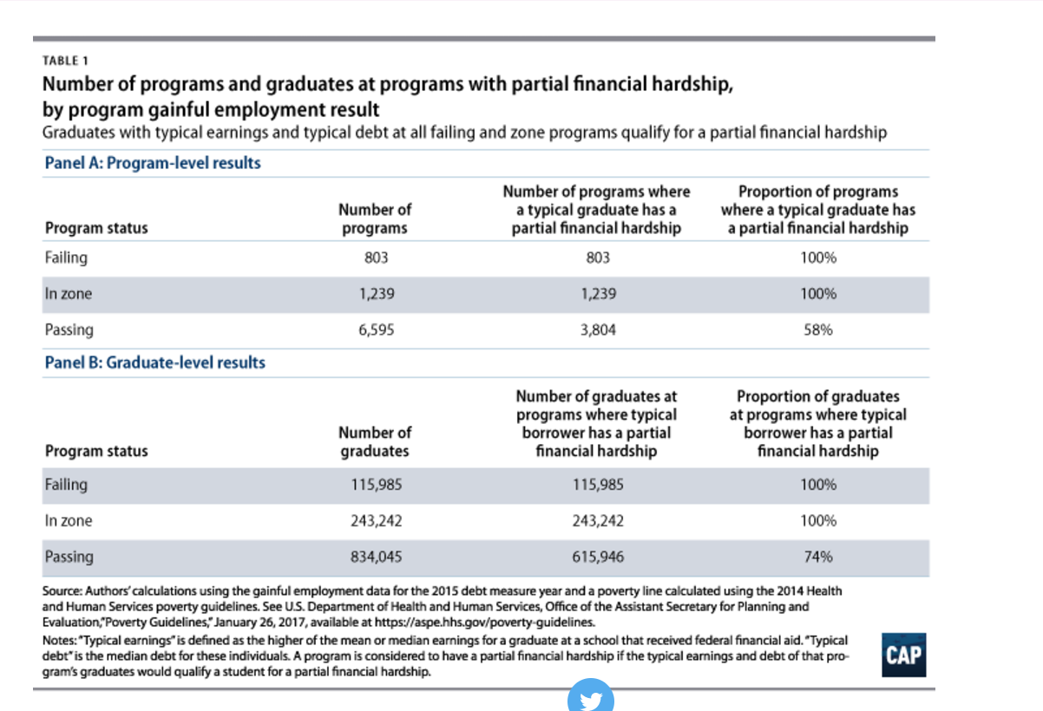
Here is how we reached that conclusion: First, we generated an estimated IDR payment for the typical graduate at each gainful employment program by taking 10 percent of the reported discretionary income. For this purpose, we used the higher of the mean or median discretionary income. Next, we used the median debt payments from each program to calculate a borrower’s loan payments on the standard 10-year plan.14 Finally, we compared the two amounts. We concluded that a program had a typical borrower with a partial financial hardship if the estimated IDR payment fell below the standard one.
The partial financial hardship is an important indicator of whether a student would benefit from using IDR. For one, having a hardship is a requirement to participate in many IDR plans. However, even when a specific plan doesn’t require it, such as REPAYE, the hardship terms indicate whether a student would stand to have a lower monthly payment in IDR plan than they would on the standard 10-year plan, and therefore whether they have an incentive to use it. Table 1 answers an important first-order question: Would the typical graduate at nonpassing gainful employment programs pay less on a monthly basis if they used IDR? There is a definitive yes for every program.

Nonpasing programs can’t repay student loans
Miller and Libassi 17 – CJ Libassi, Policy Analyst on the Postsecondary Education team at American Progress. Libassi served as a research area specialist at the University of Michigan Education Policy Initiative; an English teaching assistant at a secondary school in Madrid, Spain, through the Fulbright Program; and an elementary school foreign-language teacher in the Prince George’s County Public Schools through Teach for America. He received his master of public policy from the University of Michigan Gerald R. Ford School of Public Policy, as well as a master of arts in teaching from American University and a B.A. in English, Spanish, and philosophy from the University of Scranton, Ben Miller, Senior Director for Postsecondary Education at American Progress. Previous research director for higher education at New America, as well as a senior policy advisor in the Office of Planning, Evaluation and Policy Development at the U.S. Department of Education. Miller’s work focuses on higher-education accountability, affordability, and financial aid, as well as for-profit colleges and other issues. Miller’s work has appeared in The New York Times, the Los Angeles Times, The Chronicle of Higher Education, and Inside Higher Ed, 2017 (“How Gainful Employment Reduces the Government’s Loan Forgiveness Costs”, June 8th, Available Online at https://www.americanprogress.org/issues/education/reports/2017/06/08/433531/gainful-employment-reduces-governments-loan-forgiveness-costs/, Accessed 07-11-2017)
Result 2: Nonpassing programs are nowhere close to having the income needed to repay loans
Not only are graduates from nonpassing programs earning so little compared with their debt that they qualify for IDR, most are nowhere close to making enough to afford a standard 10-year payment. This suggests graduates would need a dramatic increase in their incomes as their careers unfold to avoid needing IDR for long periods of time—perhaps even until forgiveness after 20 or 25 years.
As Table 2 shows, typical graduates at more than 98 percent of nonpassing programs would need at least $10,000 more in annual earnings before they would cease receiving a payment reduction on IDR compared with the 10-year standard plan. Given that the average income for graduates from these programs is $18,916, that works out to a raise of more than 50 percent.
Many programs are even worse. For instance, we estimate that a majority of nonpassing programs at private, for-profit colleges would have to boost annual earnings for the typical graduate by more than $20,000 before that graduate would become ineligible for IDR. And at the extreme end, nearly one-quarter of these programs would need to increase their typical graduate’s annual earnings by $30,000.
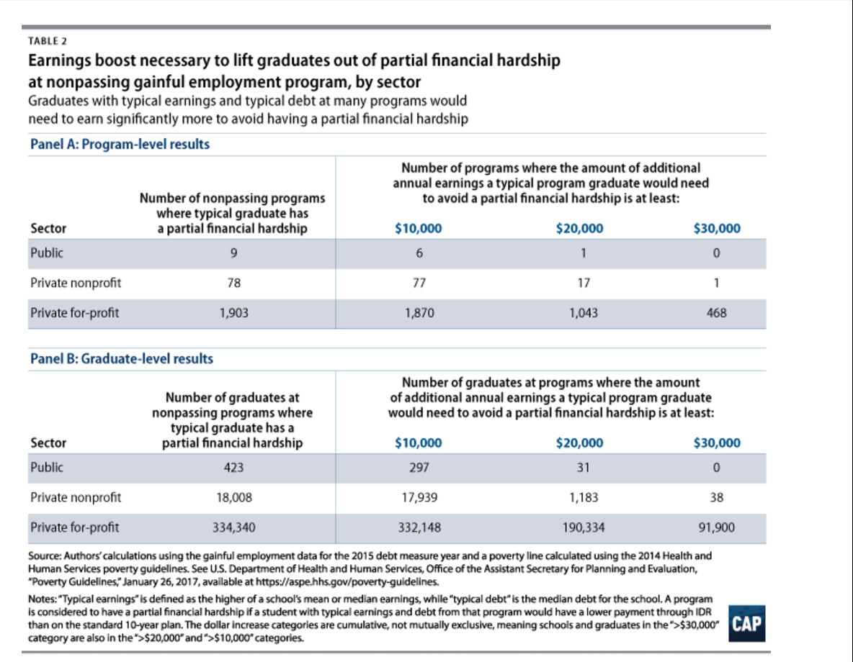

DoE studies prove gainful-employment effectiveness
Department of Education 17 – Department of Eduation, 2017, (“Education Department Releases Final Debt-to-Earnings Rates for Gainful Employment Programs”, January 9th, Available Online at https://www.ed.gov/news/press-releases/education-department-releases-final-debt-earnings-rates-gainful-employment-programs, Accessed 07-11-2017)
The U.S. Department of Education today released the first debt-to-earnings (D/E) rates for career training programs as required by the landmark Gainful Employment (GE) regulations.
The release of these rates builds on the Department’s ongoing efforts to promote college completion and increase accountability in the postsecondary education marketplace by setting standards for career training programs, including programs offered by for-profit institutions, to ensure they are serving students well. The data show that, while many postsecondary programs offer value to students, there are a significant number of career training programs—specifically for-profit programs—that do not provide their graduates with a reasonable return on investment. A new disclosure template, that will be released later this month, presents this information in a simple format and aligns with information provided on the Department’s College Scorecard.
“When a student makes a personal and financial decision to attend college, the student must feel confident that it is a sound investment in his or her future, not a liability that will further defer his or her dreams,” said U.S. Secretary of Education John B. King Jr. "These rates shed a bright light on which career training programs are most likely to prepare students for repaying their student loan debt, and which programs might leave them worse off than when they started.”
To qualify for federal student aid, the law requires that most for-profit programs and certificate programs at private non-profit and public institutions prepare students for "gainful employment in a recognized occupation." Under the regulations finalized in 2014, a program would be considered to lead to gainful employment—and passing—if the estimated annual loan payment of a typical graduate does not exceed 20 percent of his or her discretionary income or 8 percent of his or her total earnings. Programs that exceed these levels would be at risk of losing their ability to participate in taxpayer-funded federal student aid programs.
“In the career training program marketplace, accurate and straightforward information about costs and benefits helps students make well-informed decisions about where to invest their time and resources,” said U.S. Under Secretary of Education Ted Mitchell. “These data will also be important for institutions as they seek to improve their programs to better serve students and to deliver on the promises they make.”
The data indicate that over 800 programs serving hundreds of thousands students fail the Department’s accountability standards with an annual loan payment that is at least greater than 30 percent of discretionary income and greater than 12 percent of total earnings. Ninety-eight percent of these failing GE programs are offered by for-profit institutions.
“Too many for-profit colleges have misled students, leaving them unable to find jobs that earn enough to pay off their crushing debt,” said U.S. Senator Sherrod Brown. “The Department of Education’s gainful employment rule is critical in holding for-profit schools accountable and we must continue fighting to make sure students come before profits.”
An additional 1,239 programs received a “zone” rate, with an annual loan payment that is between 20 and 30 percent of discretionary income or between 8 and 12 percent of total earnings. Programs that receive four consecutive years of zone or fail rates will become ineligible for federal student aid.
The data released today provide further evidence that community colleges offer a better deal than comparable programs at for-profit colleges with higher price tags. As these new data depict, when student debt is taken into account, community colleges—where students borrow at lower rates and lower dollar amounts—perform particularly well when matched up against comparable for-profit programs.
The Department calculates debt-to-earnings rates using debt information from the Department’s records and as reported by institutions and earnings data obtained from the Social Security Administration. The debt amount used in the rate calculations uses the median total federal, private, and institutional debt that program graduates have accumulated for attendance in the program. The higher of the mean or median earnings are obtained at least two years after graduates have left a program in order to allow graduates to establish themselves in the workforce. For most programs the rates released today include students who graduated between July 1, 2010 and June 30, 2012.
Since the regulation was published, programs have had the opportunity to make immediate changes to avoid sanctions. If recent graduates left with less debt than the graduates for which we obtained earnings, we recalculated a program’s debt-to-earnings rate to reflect these improvements. If a program does not improve, it will become ineligible for federal student aid. Programs that are at risk of losing eligibility within the next year must warn current and prospective students that they may be unable to obtain federal aid for enrollment in the program.
The rule also requires institutions to provide students with other key information about their programs, including the program’s graduation rate, average earnings of graduates, average federal student loan debt, and whether programs meet state licensure requirements. In the past, low performing programs attempting to lure unsuspecting students frequently obscured this information; a standard disclosure template will provide clear information and help students to compare programs across schools.
Protecting Students from Poor-Performing Career Colleges
Too often, students in career training programs are charged excessive costs, but don't get the education they paid for. In many cases, students are drawn to these programs because of confusing or misleading information. Many receive poor quality training, often for low-wage jobs or in occupations where there are few job opportunities. And many are saddled with large amounts of debt at graduation and end up in default.

2NC – Impact – Financial Aid

It also informs students on financial aid issues
Department of Education 17 – Department of Eduation, 2017, (“Education Department Releases Final Debt-to-Earnings Rates for Gainful Employment Programs”, January 9th, Available Online at https://www.ed.gov/news/press-releases/education-department-releases-final-debt-earnings-rates-gainful-employment-programs, Accessed 07-11-2017)
In response to these concerns, the Department began extensive conversations with the higher education community in 2009 about the role of career colleges, particularly on how they could be held accountable for the outcomes of their students. The final Gainful Employment regulations followed an extensive rulemaking process involving public hearings, negotiations and approximately 95,000 public comments. The regulations, which went into effect on July 1, 2015, reflect the feedback the Department received.
The Department faced unprecedented opposition from the for-profit industry throughout the process. The U.S. District Courts for the District of Columbia and the Southern District of New York and the U.S. Court of Appeals for the District of Columbia affirmed the Department’s regulations, rejecting the industry’s attempts to fight basic accountability measures – a clear sign that the courts continue to recognize both the Department’s legal authority and its reasonable approach in establishing these important consumer protections.
Even prior to today’s data release, these regulations have already influenced the field. Some of the largest institutions have instituted trial periods for programs before students have to commit, so students can decide if the program is right for them. Many institutions have reduced costs for students, and others have closed locations and programs they judge to be performing poorly. The Department previously estimated there were over 37,000 distinct GE programs in 2014. Today, there are fewer than 29,000.
The Gainful Employment regulations complement efforts to protect students by addressing problems at poor performing institutions, particularly in the for-profit sector. These efforts include:
Borrower Defense to Repayment Regulations: The Department published final regulations that protect student borrowers from misleading and predatory practices by postsecondary institutions and clarify a process for loan relief in cases of institutional misconduct. The regulations also protect taxpayers by ensuring that financially troubled institutions provide the government with protection against the risks they create.
Keeping student debt affordable: The Department is helping more students manage their student debt through flexible repayment options like the Pay As You Earn plan, which caps student loan payments at 10 percent of a borrower's discretionary income. In addition, the Administration continues targeted outreach to help borrowers who may be struggling to repay their loans, ensuring that they have the information they need to select the best repayment option for them and avoid future default.
Releasing the College Scorecard and Financial Aid Shopping Sheet: The Department has worked to create user-friendly tools that put information in the hands of students and families to help them make decisions about where to go to school. The Financial Aid Shopping Sheet allows institutions to provide standardized information about costs and financial aid so students can easily compare institutions and make informed decisions. The redesigned College Scorecard, launched in September 2015, is a consumer tool that provides clear, accessible, and reliable comprehensive national data on cost, graduation, debt, and post-college earnings.

2NC – Impact – IDR Loans

It prevents massive IDR loan defaults
Miller and Libassi 17 – CJ Libassi, Policy Analyst on the Postsecondary Education team at American Progress. Libassi served as a research area specialist at the University of Michigan Education Policy Initiative; an English teaching assistant at a secondary school in Madrid, Spain, through the Fulbright Program; and an elementary school foreign-language teacher in the Prince George’s County Public Schools through Teach for America. He received his master of public policy from the University of Michigan Gerald R. Ford School of Public Policy, as well as a master of arts in teaching from American University and a B.A. in English, Spanish, and philosophy from the University of Scranton, Ben Miller, Senior Director for Postsecondary Education at American Progress. Previous research director for higher education at New America, as well as a senior policy advisor in the Office of Planning, Evaluation and Policy Development at the U.S. Department of Education. Miller’s work focuses on higher-education accountability, affordability, and financial aid, as well as for-profit colleges and other issues. Miller’s work has appeared in The New York Times, the Los Angeles Times, The Chronicle of Higher Education, and Inside Higher Ed, 2017 (“How Gainful Employment Reduces the Government’s Loan Forgiveness Costs”, June 8th, Available Online at https://www.americanprogress.org/issues/education/reports/2017/06/08/433531/gainful-employment-reduces-governments-loan-forgiveness-costs/, Accessed 07-11-2017)
Result 3: Nonpassing programs will likely generate significant forgiveness costs
So far, we have examined the implications of the gainful employment debt and earnings data for the payments a borrower would make in a single year. However, repayment outcomes are determined over the life of a loan. Unfortunately, the prospects of graduates from many of these programs are not any rosier over the long term. In fact, we estimate that, if graduates from nonpassing programs made use of IDR plans, the government would receive $1.5 billion less on these loans in present discounted terms compared with what borrowers using the standard 10-year plan would repay.
To understand the government’s potential exposure to losses from student loan forgiveness, we calculated the total amounts a typical graduate from nonpassing programs would pay if they stayed on the REPAYE plan—an IDR option available to borrowers that is less likely to generate forgiveness than other plans. We looked at borrowers’ results on REPAYE until they paid off their loan or received forgiveness.15 An explanation of how we modeled REPAYE can be found in the methodology. (see Appendix A) We then compared those amounts, in net present value, to what those graduates would have paid in total under the standard 10-year plan.
The first thing our modeling shows is that, were they to use REPAYE, the typical graduate from every failing or zone program would receive some amount of loan forgiveness. In other words, these graduates earn so little relative to their debt that even two decades or more of payments tied to income are insufficient to pay off their debts.
Figure 1 shows just how slowly typical graduates from such programs pay off their loans. For both graduate and undergraduate career training programs that do not pass the debt-to-earnings test, debt levels start high and are paid down slowly. By contrast, passing programs start off with lower initial loan balances and typically pay down completely by the end of the IDR repayment term of either 20 or 25 years.
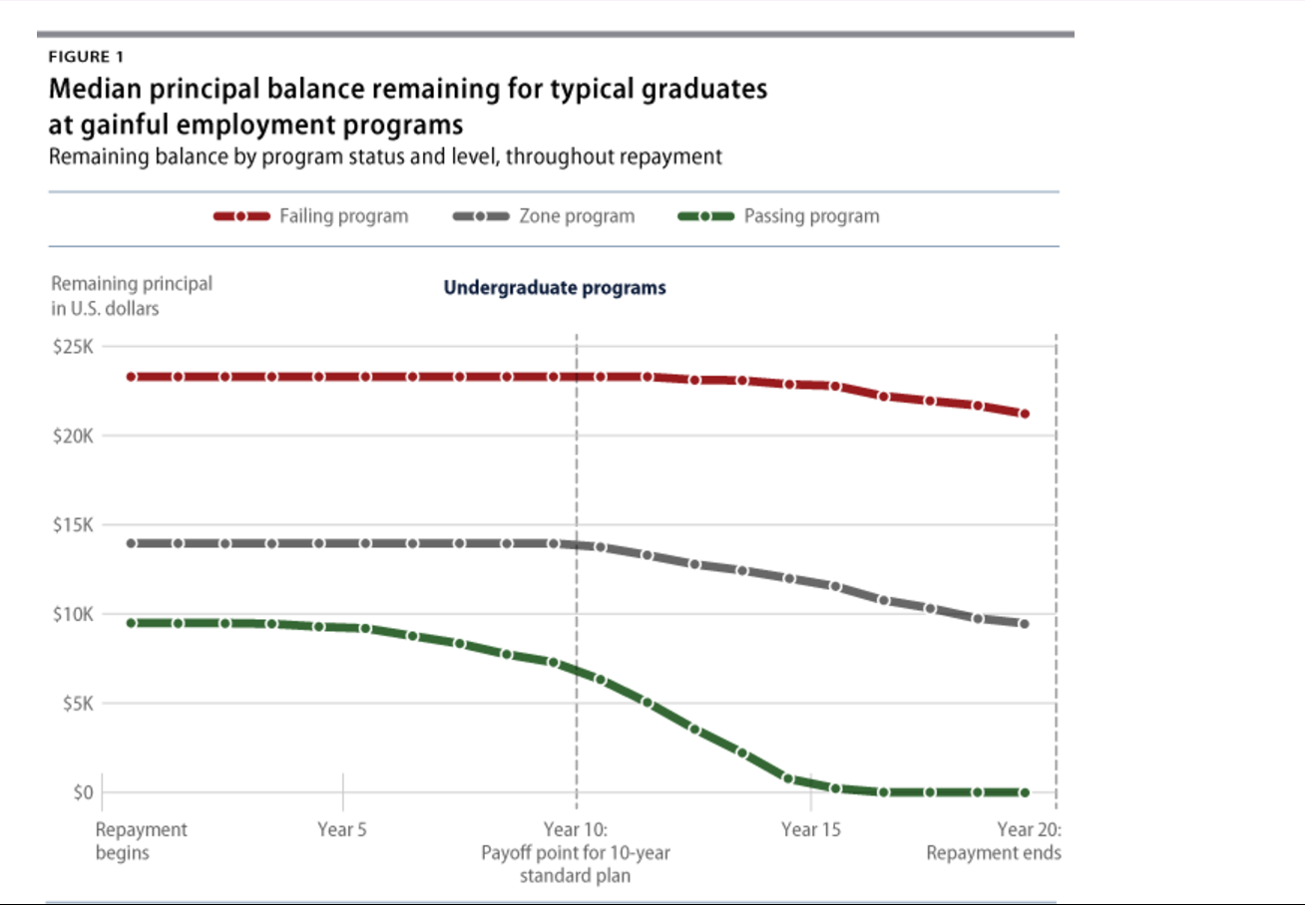
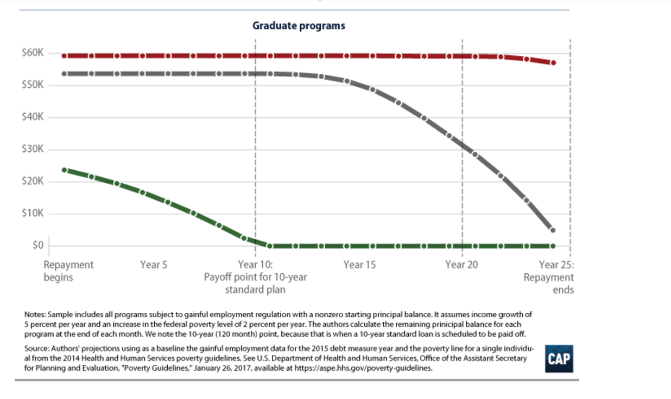
Second, we find that the projected forgiveness amounts are substantial. As Figure 2 shows, typical graduates at more than half of failing programs in the gainful employment data would have at least $40,000 forgiven in nominal terms. Zone programs have a smaller—but still considerable—median forgiveness amount, at just under $20,000. By contrast, nearly all passing programs pay off, and those that do not have very small projected forgiveness amounts.
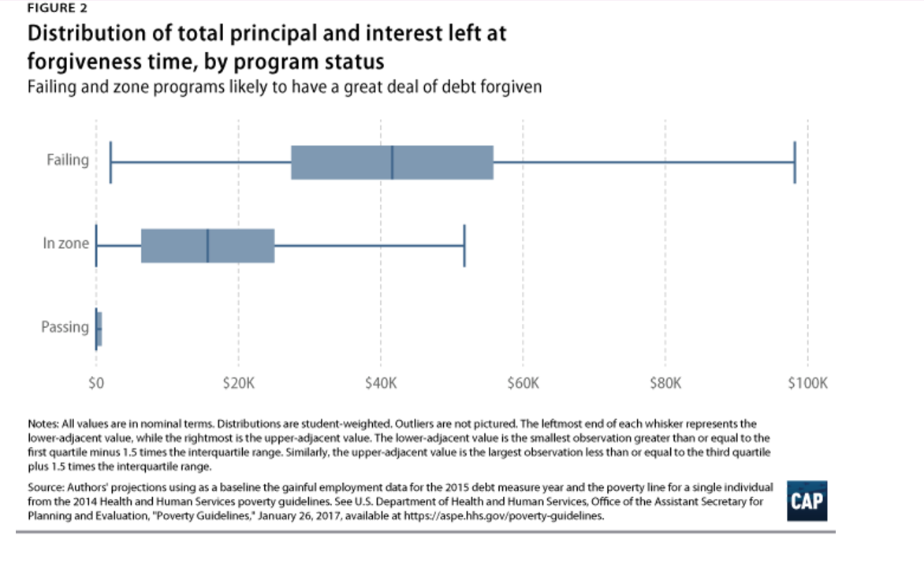
However, these forgiveness estimates should not be confused with the loss to the government. Because students in IDR are likely to accumulate more interest and pay down principal more slowly than they would under a standard 10-year plan, it is possible for a student to repay more in total to the government under IDR than they would on the standard 10-year plan and still receive loan forgiveness. A simplified example (with all figures discounted to present dollars) shows how this works. Imagine the government expects to receive $14,000 in repaid principal and interest from a borrower using the standard 10-year plan. That borrower instead goes on IDR, where they repay $16,000 in principal and interest but still receive $1,000 in forgiveness. In this case, the government has not taken a loss because it still recovered more from the borrower than it originally expected.
To get a sense of how much less the government can expect to be repaid by graduates at nonpassing career training programs, we calculated a repayment gap—the difference between the total amount a typical graduate from each program would repay the government on a 10-year standard plan versus REPAYE, discounted to present dollars. For example, if we project that the government would receive $12,000 from a borrower using the 10-year standard plan and $11,000 from REPAYE, then the repayment gap is -$1,000.
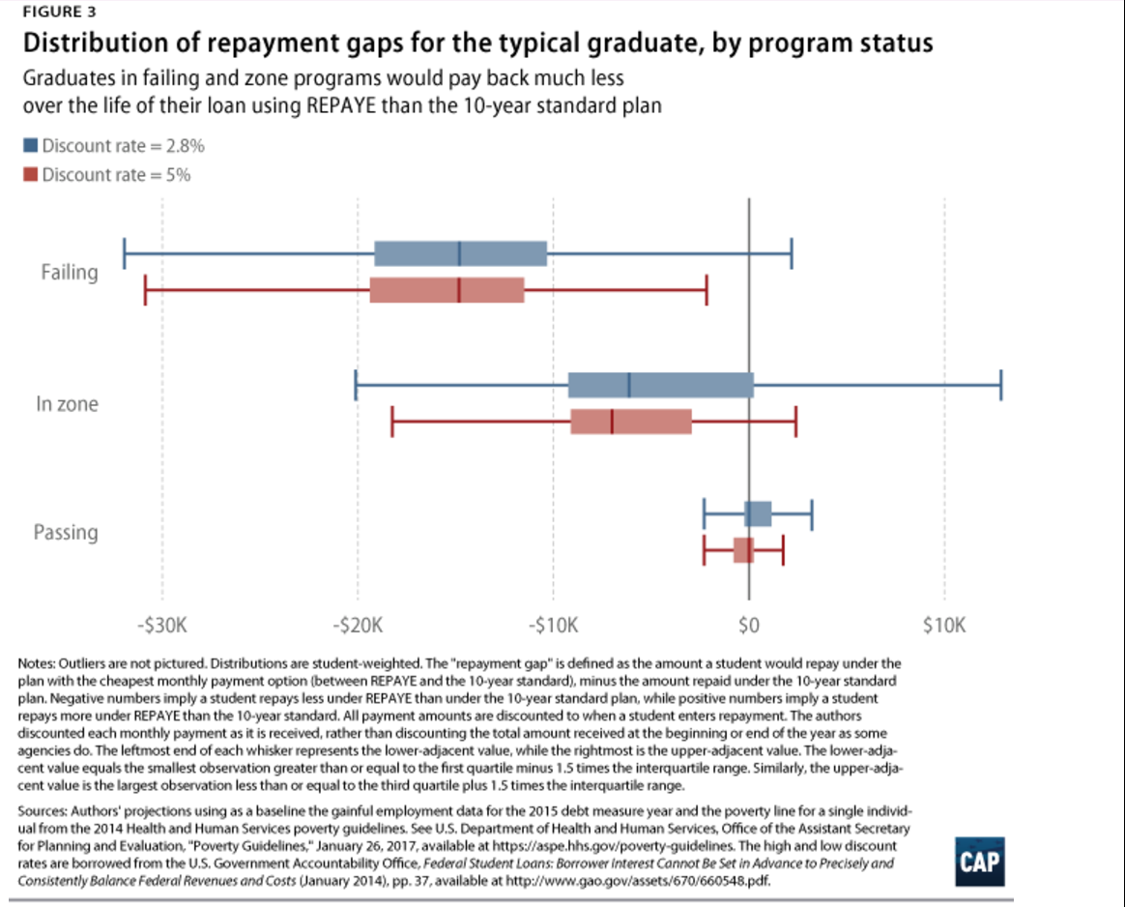
Under this repayment comparison, we find that roughly half of failing programs’ typical graduates have a repayment gap of -$15,000. The median zone program, meanwhile, has a typical graduate with a repayment gap of roughly -$6,000.16
All told, we estimate the national repayment gap from one year of data on nonpassing gainful employment to be -$1.5 billion. We arrive at this projection by multiplying the repayment gap estimate for the typical graduate at each nonpassing program by half the number of reported graduates at each program. We decided not to use the total number of graduates because it is possible every school has some borrowers who will have incomes high enough that they are unlikely to use REPAYE. While that number may not be as high as half at each program, we choose this share because the income figures used reflect the higher of the mean or median for the school. This means that at least half the graduates from a program have earnings at or below the level used for our modeling. Thus, a qualification rate of half of all graduates is an absolute lower bound.17
Projecting the repayment gap only off the number of graduates also likely understates the total revenue loss from nonpassing gainful employment programs. As noted in the second finding, the typical graduate at almost all nonpassing programs is considerably far from not having a partial financial hardship. Thus, even graduates well above the median or mean income would likely still benefit from IDR. In addition, looking at the number of graduates fails to account for the substantial number of students who drop out of gainful employment programs.18 Though students who drop out likely have lower debt levels than graduates, they also probably make less money and may be even more likely to need REPAYE.
The way the gainful employment rule calculates a graduate’s typical debt payment also likely understates the repayment gap. The rule affords institutions the ability to limit the loan amounts used to judge their debt-to-earnings ratios to just the amount charged for tuition, fees, and required expenses. As a result, graduates may have taken on additional debt for living expense that is not reported and also not repaid.

Gaining Employment law fosters IDR loans independence
Miller and Libassi 17 – CJ Libassi, Policy Analyst on the Postsecondary Education team at American Progress. Libassi served as a research area specialist at the University of Michigan Education Policy Initiative; an English teaching assistant at a secondary school in Madrid, Spain, through the Fulbright Program; and an elementary school foreign-language teacher in the Prince George’s County Public Schools through Teach for America. He received his master of public policy from the University of Michigan Gerald R. Ford School of Public Policy, as well as a master of arts in teaching from American University and a B.A. in English, Spanish, and philosophy from the University of Scranton, Ben Miller, Senior Director for Postsecondary Education at American Progress. Previous research director for higher education at New America, as well as a senior policy advisor in the Office of Planning, Evaluation and Policy Development at the U.S. Department of Education. Miller’s work focuses on higher-education accountability, affordability, and financial aid, as well as for-profit colleges and other issues. Miller’s work has appeared in The New York Times, the Los Angeles Times, The Chronicle of Higher Education, and Inside Higher Ed, 2017 (“How Gainful Employment Reduces the Government’s Loan Forgiveness Costs”, June 8th, Available Online at https://www.americanprogress.org/issues/education/reports/2017/06/08/433531/gainful-employment-reduces-governments-loan-forgiveness-costs/, Accessed 07-11-2017)
As the political climate in Washington shifts in favor of deregulation, the gainful employment rule has become one of the most endangered protections for college students. When fully implemented, the rule will terminate federal student aid eligibility for career training programs that leave their graduates with too much debt relative to their earnings.1 Without this rule, hundreds of thousands of students run the risk of paying large sums of money to attend low-quality programs that leave them underemployed and mired in debt. These students would either face a lifetime of financial hardship or rely on payment plans based on their income that have long repayment terms and accumulate great deals of interest before ultimately obtaining taxpayer-supported loan forgiveness. The real winners would be colleges offering these low-value programs that would continue to pad their revenues with government-funded student loans.
While proponents and critics have debated the necessity of the gainful employment rule for years, critics of the rule have too often glossed over one of its crucial effects: Enforcing a strong regulation saves taxpayers money. To date, only a few estimates have tried to capture the financial effects of gainful employment. A preliminary score from the Congressional Budget Office (CBO), for example, suggests that undoing the rule would increase taxpayer spending by $1.3 billion over 10 years.2 The U.S. Department of Education, meanwhile, estimated that the rule would save the public approximately $4.2 billion over 10 years due to reductions in federal financial aid spending.3
Neither of these two estimates, however, appear to measure another important source of taxpayer savings: reduced long-term loan forgiveness costs. By prohibiting federal lending at programs where debt levels far exceed a reasonable share of earnings, the gainful employment rule protects taxpayers from government-funded loans where low graduate earnings are likely to translate into substantial publicly funded loan forgiveness.
In this brief, we attempt to quantify the savings that gainful employment could generate from reduced long-term loan forgiveness costs. Using Department of Education data released in January 2017, we estimate that the typical graduate4 who received federal financial aid at each one of the 2,042 career training programs that fail to abide by the gainful employment rule has a student loan burden that would qualify for payment relief under income-driven repayment (IDR)—a group of programs that allow borrowers to make lower monthly payments based upon their income and forgive remaining amounts after 20 or 25 years in repayment.5
IDR plans are a safety net for those who are struggling. They are a vital resource for borrowers who work in fields with lower earning potential—such as public service—or who go through extended periods of financial hardship. However, without gainful employment regulations, low-performing programs leave large groups of borrowers with few options besides IDR plans, which extend borrowers’ time in repayment; increase the amount of interest they pay; and could increase the amount the government spends on loan forgiveness.
In fact, given their incomes, graduates in nonpassing gainful employment programs are so over-indebted that they would have to see improbably high levels of earnings growth to make enough money to pay down their debt, according to our analysis. Absent such massive changes in income, we project that typical graduates from a troubled gainful employment program would pay back so little of their loan under an IDR plan that they would end up receiving approximately $22,000 in forgiveness after 20 or 25 years in repayment.6 In aggregate, the loans at nonpassing gainful employment programs represent a substantial potential cost to the government. Given that nonpassing gainful employment programs graduated approximately 360,000 students primarily in 2011 and 2012—the most recent cohort with available debt and earnings data—we project the government will receive $1.5 billion less on these loans in present discounted terms compared with what taxpayers would receive from those loans repaid under the standard 10-year payment plan.
These findings highlight the importance of striking a balance between preserving IDR as a benefit for struggling borrowers while ensuring taxpayer-subsidized repayment plans are not used to bail out low-quality institutions and programs. IDR, after all, is a benefit for students that provides crucial insurance against life’s ups and downs and guarantees that loans will never eat up more than a set share of graduates’ income. IDR is not supposed to help colleges offer low-quality programs at a high price or make promises to students that they cannot fulfill.
If Congress or the Department of Education terminates the gainful employment rule, educational institutions would be able to sidestep issues of educational quality, economic return, and value by offering programs whose graduates will only be able to repay their debt using an IDR plan that spans two decades or more. These situations turn a benefit for struggling students into a de facto taxpayer-funded bailout for institutions that overcharge students.
The gainful employment rule provides an appropriate balance between preserving student benefits and ensuring IDR cannot be abused by career training programs. Because of the thresholds it sets for unacceptable levels of debt, only programs whose graduates’ incomes fall far below the levels necessary to avoid needing IDR will be at risk of losing access to federal aid. Programs where reasonable income growth might allow borrowers to eventually repay are unaffected. And even if a given program loses access to aid, its past borrowers can still make use of the loan repayment safety net.
For many years, the absence of rules such as gainful employment allowed low-value programs to saddle students with debt, limiting borrowers to only one option for long-term repayment success: programs such as IDR that entail longer repayment periods and eventual taxpayer-funded forgiveness. While it is too late for the rule to affect the futures of students who have already graduated, it will be a powerful tool for shrinking taxpayers’ future loan forgiveness liability in addition to protecting students from low-value programs.

2NC – Impact – Social Security

Student debt forces social-security cuts and impoverishes the elderly
Douglas-Gabriel 16 – Danielle Douglas-Gabriel, Reporter for the New York Times that covers the economics of education, writing about the financial lives of students from when they take out student debt through their experiences in the job market, 2016 (“The disturbing trend of people losing Social Security benefits to student debt”, December 20th, Available Online at https://www.washingtonpost.com/news/grade-point/wp/2016/12/20/the-disturbing-trend-of-people-losing-social-security-benefits-to-student-debt/?utm_term=.0ac8b60a4046, Accessed 07-11-2017)
To recoup student-loan debt, the government is leaving people who rely on Social Security with benefits that fall below federal poverty guidelines, the Government Accountability Office said Tuesday.
The number of older Americans defaulting on education loans has steadily increased in recent decades, as many have returned to college or co-signed loans for family members. Unpaid debt has resulted in the government garnishing the benefits of 114,000 people age 50 and older in the past year, more than half of whom were receiving Social Security disability rather than retirement income, the GAO report said.
Garnishment exacerbates an already precarious financial situation for the 67,300 older borrowers who receive benefits below the poverty guideline, which is set at about $990 a month for a single adult. Even though no more than 15 percent of a recipient’s monthly Social Security payments can be taken in debt collection, that threshold has never been adjusted to reflect the increased cost of living.
“We can’t be garnishing people’s Social Security in a way that puts them into poverty,” said Sen. Claire McCaskill (Mo.), the ranking Democrat on the Senate Special Committee on Aging. “We need to make sure that we have adjusted the ability of the government to recover those loan amounts in a way that is not spiraling people into poverty.”
[A senator calls attention to the struggle of seniors losing Social Security benefits to student debt]
In April 2015, McCaskill and Sen. Elizabeth Warren (D-Mass.) asked the GAO for information about the money that seniors are left with after their payments are cut, the average duration of garnishment, the effect of student debt on retirement savings and the number of recipients who die without paying off their loans, among other things.
Researchers found that at the time of their initial Social Security garnishment, nearly half of borrowers age 50 and older had held their student loans for 20 years or more. A majority of these borrowers owed less than $10,000 when their benefits were first cut and many were hit with the maximum reduction, the GAO said. Seventy percent of the money collected through this form of garnishment from borrowers of all ages was applied to fees and interest, not the principle amount owed. Treasury charges a $15 monthly processing fee for wage and benefit garnishment.
And although Social Security cuts for many older Americans ended within a year, those with balances exceeding $20,000 endured the reduction for five years or more, according to the report. About 13 percent of borrowers older than 50 died with outstanding student loans.
Some people have been granted financial hardship exemptions, while others have successfully applied for permanent disability discharge of their loans through the Education Department. But researchers at the GAO are critical of the agency’s byzantine application process that puts borrowers at risk of falling back into garnishment. If people do not submit annual documentation to verify their income, their loans can be reinstated and the cuts can resume.
The Obama administration has been identifying severely disabled borrowers and guiding them through the steps to discharge their loans. With the help of the Social Security Administration, education officials found 179,000 permanently disabled people in default on their loans earlier this year. Advocacy groups, however, worry that people are still falling through the cracks.
[Obama to forgive the student debt of permanently disabled people]
“Our government is shoving tens of thousands of seniors and people with disabilities into poverty through garnishment every year — and charging them $15 every month for the privilege — just so that the Department of Education can collect a little bit more interest and keep boosting the government’s student loan profits,” Warren said. “This is predatory and counterproductive.”
At the end of last year, Warren co-sponsored legislation that would exempt Social Security benefits from being garnished by the government. Although the bill stalled in committee, she is urging Congress to revisit the legislation in light of the GAO’s findings.
Researchers at the GAO are calling on lawmakers to adjust the 15 percent limit to reflect cost-of-living changes, and for the Education Department to clarify requirements for disability discharge. McCaskill said she plans to introduce legislation that would bar Social Security from being garnished if it places people below the poverty line.
“Even Scrooge would hesitate to say it’s a good idea for the government to be putting Social Security recipients into poverty trying to recover payments on student loans,” she said.
Seizing paychecks, tax refunds and Social Security benefits has long been a controversial way to collect on taxpayer-funded college loans. The government uses the same tactics to recoup child support and unpaid taxes. It is usually a last resort, but one that can really harm seniors relying on disability or retirement benefits.
[More seniors are carrying student loan debt into retirement]
There has been a 10-fold increase in the amount of student debt held by people age 65 and older, from $2 billion in 2005 to $22 billion a decade later. Even though people younger than 50 hold the largest amount of debt, a greater share of older borrowers were in default on their student loan and became subject to garnishment last year.

2NC – Impact – Student Debt = Econ Collapse

Student debt causes economic decline.
Gorman 15 [Ryan Gorman, economic journalist citing Rutgers University financial resource management specialist, May 1, 2015, “How student-loan debt is dragging down the economy”, Business Insider, http://www.businessinsider.com/3-charts-explain-the-effect-of-student-loans-on-the-economy-2015-5] A.S.
Student-loan balances have skyrocketed over the past decade, and that could have a very negative effect on the economy. Outstanding student loans have nearly quadrupled since 2004, to just under $1.2 trillion, according to the Federal Reserve Bank of New York. This happened as student-loan defaults have nearly doubled over that same time. The average student-loan balance among people with bachelor's degrees has risen from $15,000 in the mid-1990s to about $27,000, according to the Fed. This is having a crippling effect on economic activity, says Barbara O'Neill, a specialist in financial resource management for Rutgers University. "A lot of things are being postponed. You got what you call a crowding-out effect — people only have so much money," she said. "There’s a lot of business activity that isn’t taking place ... It’s a drag on everything." Fewer people are buying homes and cars, O'Neill says, because large portions of their income are being eaten up by student loans. They're also less likely to start the small businesses that provide jobs and services that drive the economy. "It has tremendous effects," O'Neill said. "There’s also evidence entrepreneurial activity is down. When you have that big student-loan debt over your head, you're less likely to take risks." This rise in borrowing, and the increasing number of people who are having a harder time paying off these debts, has led many to ask if student loans are the next bubble to burst. Delinquent loans Student-loan delinquencies have steadily risen despite other late payments dropping.Federal Reserve Bank of New York The 90-day delinquency rate for student loans has risen to 11.3%. For context: The rate for mortgages has dropped to about 3.1%, and credit-card delinquencies have reached historical lows, according to the Fed. One fact: Delinquency is not limited to borrowers who took out huge loans to attend law or medical schools, according to William Elliot, director of the School of Social Welfare at the University of Kansas. “What’s interesting is that it’s not just people with high amounts of debt having delinquency problems,” Elliot told Business Insider. “Even people with only $5,000 or $10,000 are still going delinquent.” The hardest-hit age group, according to the chart below, has been people in their 30s. Thirty-somethings have seen their outstanding student loans nearly triple since 2014 as they returned to college during the downturn or attended graduate school because loans became more accessible. Debt on the rise Even more surprisingly, student-loan balances among those in their 30s have more than doubled.Federal Reserve Bank of New York Student loan debt, more than any other kind, contributes to people having less favorable views on their own financial well-being, according to Elliot, which is why the dramatic rise in borrowing for school over the last decade by more than 40 million Americans may be hindering economic recovery. "If large and increasing numbers of student borrowers default on their loans, the resultant damage to their credit ratings would likely preclude home-secured borrowing in the tight lending environment that has prevailed for the last several years," according to the Fed. Elliot largely agreed with this sentiment. “People are less likely to own homes or have retirement savings — by significant amounts,” he said. O'Neill reinforced this point. "Baby boomers can’t sell houses because millennials can't afford to buy them, that’s huge," she said. "The clearly is a relationship there — just talk to anybody trying to sell a home." Elliot warned that no study has proved the direct correlation between student-loan debts and a drag on the economy, but agreed that the debts are associated with bad outcomes that can lead to less spending. "It’s a drag on the economy because purchases aren’t being made," said O'Neill. "It’s probably dragging down our GDP." The less people spend, the slower the economy’s recovery will be.

Student debt causes econ decline –inflation.
Collinge 16 [Alan Collinge, economic journalist, "Student debt is America's most pressing economic problem," The Hill, http://thehill.com/blogs/pundits-blog/economy-budget/309760-student-debt-is-americas-most-pressing-economic-problem] A.S.
Since 2000, U.S. student loan debt has grown to overwhelm all other categories of non-housing consumer debt in this nation. The lending instrument is uniquely predatory in that student loans have been stripped of the most fundamental consumer protections, such as bankruptcy rights, statutes of limitations and many others. This has created a massively inflationary market place, exploding debt loads and has wreaked economic havoc upon tens of millions of citizens who borrowed or cosigned student loans. This problem currently affects 44 million borrowers, a majority of whom are currently unable to make payments on the debt. It threatens untold millions more as this problem really begins to hit home in living rooms across the nation. The human cost of this phenomenon cannot be understated. Families and individuals are being financially destabilized and wrecked. Family formation, home and other purchases are being delayed or cancelled, people are actually fleeing the country and even committing suicide as a result of this predatory debt. In this century, the problem traces back to the Clinton years, when bankruptcy discharge was made permanently impossible, for all intents, through the Higher Education Act amendments in 1998, but was exacerbated in 2005 when bankruptcy rights were similar deleted for private student loans. While George W. Bush, John Boehner, Lindsey Graham and their allies in Congress—having been showered with support by the lending industry—made this problem worse by extending the bankruptcy exception to private loans, it was expected that President Obama and the supermajority Democratic Congress would at least return the standard consumer protections that should never have been taken away. Neither Obama or his Congress even tried. In fact, it was the the Blue Dog Democrats in the House who were key in defeating a bill that would have returned bankruptcy protections to private loans in 2007. Obama kicked the private banks out of the lending program, but this did nothing to make the lending system better for students. In fact, interest rates went up slightly. What this did achieve was to make the Department of Education astonishingly profitable. The agency now books some $50 billion in profits on the lending system annually and continues to astonishingly make a profit on defaulted loans. The Department of Education, which is run largely by people brought in from the lending industry, now busies itself protecting its cash cow and fights tooth and nail behind the scenes to ensure that bankruptcy, statutes of limitations and other bedrock consumer protections remain gone. It is worth noting, here, that under Barack Obama, nearly $1 trillion was added to the nation's student debt tab. What is worse, the various “forgiveness” programs that have been put into place over the past decade are not working, and will never work, because the Department of Education has no desire or intention of forgiving anyone's student loans (the agency abandoned any pretense of serving the public interest years ago, but that is another story). Already a whopping 57 percent of the people in the Income Based Repayment (IBR) program have been kicked out of the program on just one of the many premises available to the Department of Education for expelling people from the program, which is failing to verify income. This is something that the agency could and should verify independently through the Internal Revenue Service, but doesn't because it would hurt its bottom line. It would be surprising if more than 15 percent of the people applying for these forgiveness plans actually make it through. The most recent presidential campaigns were cruel jokes when it came to the student loan issue. Hillary Clinton and Bernie Sanders touted “free tuition” plans that, even if they worked, would only have affected undergraduates at public colleges, or about 5 million of the 20 million students in the country. These plans would have done nothing for the 44 million citizens now trapped under nearly $1.5 trillion in debt, and would have done nothing to bring down the price of college. Clinton's refinancing plan was so inconsequential as to deserve no more discussion beyond the completion of this sentence. Donald Trump's initial comments on the student loan problem, where he decried the obscene profiteering by the Department of Education, were encouraging, but his student loan plan was a cowardly refinement on Obama's “Pay As You Earn” forgiveness plan. While this issue is absolutely teed up for Trump, he whiffed it during the campaign. Hopefully he will take the time to actually think about this problem going forward. Trump would do well ignore the student loan swamp people like David Bergeron, Jason Delisle and many others who are undoubtedly laying the groundwork to perpetuate this predatory lending system. The swamp must be drained, not listened to. Trump should talk to Ike Brannon, Robert Reich, David Brooks or even Jeb Bush on this. Conservatives and liberals like these are now stating the obvious: That bankruptcy protections must be returned to student loans. Better yet, Trump should simply heed the wisdom of the Founding Fathers, who demanded a “uniform system of bankruptcies” when they gave Congress its powers. The first 16 years of this century have been a display of political cowardice, crony capitalism, the worst sort of big government and neglect of citizens when it comes to student loans. If Trump doesn’t want to preside over the evaporation of the entire student loan system into a mist of illegitimacy, he must command his Congress to, at a minimum, repeal part of the U.S. bankruptcy code dealing with the “undue hardship” of student loans. He must make bankruptcy the same for student loans as it is for every other type of loan in the country. Any other action, short of canceling all student loan debt, will absolutely result in disaster. Alan Collinge is the founder of StudentLoanJustice.org and author of The Student Loan Scam: The Most Oppressive Debt in U.S. History and How We Can Fight Back.

2NC – GE – AT: Applied Narrowly

The gainful employment rule applies broadly
Itzkowitz 17 – Michael Itzkowitz, Senior policy advisor for higher education at Third Way. He is also the former director of the College Scorecard at the U.S. Department of Education, 2017 (“How the “Gainful Employment” Rule Protects Students and Taxpayers”, January 5th, Available Online at http://www.thirdway.org/memo/how-the-gainful-employment-rule-protects-students-and-taxpayers, Accessed 07-11-2017)
Who is covered by the gainful employment rules?
While most people talk about the gainful employment rules as if they apply only to the for-profit sector, the regulations actually cover over 29,000 programs at all types of institutions, including many programs at for-profit schools and non-degree and certificate (career) programs at private and public colleges.4 In fact, almost 3 in 10 (29%) of the programs covered within the most recent gainful employment data are at public colleges, including programs like the nursing program at Long Beach City College in California or the pharmacy technician program at Clark College in Washington.5 Overall, this rule encompasses programs serving over 16 million students enrolled between 2008 and 2014. In 2013-2014 alone, there were over 2.6 million newly-enrolled students in career education programs that were covered by these gainful employment protections.6

Affirmative Answers

2AC – Regulation Inevitable

Link inevitable – DeVos will crack down on states and regulate state curriculum
Green 17 – Eric L. Green, New York Times Columnist and Reporter, 2017 (“De Vos's Hard Line on New Education Law Surprises States”, July 7th, Available Online at https://www.nytimes.com/2017/07/07/us/politics/devos-federal-education-law-states.html?mcubz=0, Accessed 07-11-2017)
Education Secretary Betsy DeVos, who made a career of promoting local control of education, has signaled a surprisingly hard-line approach to carrying out an expansive new federal education law, issuing critical feedback that has rattled state school chiefs and conservative education experts alike.
President Barack Obama signed the Every Student Succeeds Act in 2015 as the less intrusive successor to the No Child Left Behind law, which was maligned by many in both political parties as punitive and prescriptive. But in the Education Department's feedback to states about their plans to put the new law into effect, it applied strict interpretations of statutes, required extensive detail and even deemed some state education goals lackluster.
In one case, the acting assistant secretary' for elementary and secondary education, Jason Botel, MT0te to the State of Delaware that its long- term goals for student achievement were not "ambitious."
"It is mind-boggling that the department could decide that it's going to challenge them on what's ambitious," said Michael J. Petrilli, the president of the conservative-leaning Thomas B. Fordham Institute, who worked in the Education Department under President George W. Bush. 1--1e called the letter "directly in opposition to the rhetoric and the promises of DeVos."
After more than a decade of strict federal education standards and standardized testing regimes, the Every Student Succeeds Act was to return latitude to the states to come up with plans to improve student achievement and hold schools accountable for student performance.
It sought to relieve states from the federal pressures of its predecessor, which required that 100 percent of the students of every school reach proficiency on state tests or the school would face harsh penalties and aggressive interventions. Unlike No Child Left Behind, the new law does not set numerical achievement targets, nor does it mandate how a state should intervene if a school fails to reach them. The law does require that states set such benchmarks on their own.
Proponents, especially congressional Republicans and conservative education advocates, believed that a new era of local control would flourish under Ms. DeVos, who pointed to the new law as illustrative of the state-level empowerment she champions.
But her department's feedback reflects a tension between ideology and legal responsibility: While she has said she would like to see her office's role in running the nation's public schools diminished, she has also said she will uphold the law.
"All of the signals she has been sending is that she's going to approve any plan that follows the law," Mr. Petrilli said. "And when in doubt, she's going to give the states the benefit of the doubt."
Mr. Botel defended the department's feedback, saying it was measuring state plans against federal statutes — including a requirement that plans be ambitious.
"Because the statute does not define the word 'ambitious,' the secretary has the responsibility of determining whether a state's long-term goals are ambitious," Mr. Botel said.
In the department's letter to Delaware — which incited the most outrage from conservative observers — Mr. Botel took aim at the state's plan to halve the number of students not meeting proficiency rates in the next decade. Such a goal would have resulted in only one-half to two thirds of some groups of students achieving proficiency, he noted. The department deemed those long-term goals, as well as those for English-language learners, not ambitious, and directed the state to revise its plans to make them more so.
So far, 16 states and the District of Columbia have submitted plans, and more states will present plans in the fall. Delaware, New Mexico and Nevada were the first three to be reviewed by Education Department staff and a panel of peer reviewers.
State education officials in Delaware said they had spent a year engaging the community on their plan and would resubmit it with clarifications.
But Atnre Alleyne, the executive director of DelawareCAN, an advocacy group that helped draft the plan, agreed with the department's findings.
He said that his group had challenged the state about accountability measures, such as setting firm goals and consequences for failing to meet them, and found that "there was a lot of fear about being bold or aggressive" after No Child Left Behind.
"Ultimately this has to be about every student succeeding, so to say that one-third are going to be proficient in 10 years, the department is right to call that into question," Mr. Alleyne said. "A lot of people thought it was just going to be a breeze. I was glad to see it was a push."
Since Ms. DeVos was confirmed, civil rights and education advocates have expressed concern that state plans would get assembly-line approval and states would be allowed to skirt responsibility for low- performing and historically underserved students.
For all of its flaws, the No Child Left Behind Act was praised for holding schools accountable for performance data. Under the law, a school was considered failing if all of its student groups, including all racial and ethnic groups, English-language learners and students with disabilities, did not meet annual achievement targets. By the end of the law, more than half of the nation's schools were considered failures.
But even after the first round of feedback, the advocates would like the department to be more aggressive and reject any state plan that lacks specifics on how they will account for the performance of historically underperforming and underserved student populations.
"Pushback and feedback in and of themselves are of no interest and of no value," said Liz King, the director of education policy at the Leadership Conference on Civil and Human Rights.
Chad Aldeman, a principal at Bellwether Education Partners, who led an independent examination of state plans, said that some states, like Louisiana, New Mexico and Tennessee, had innovative plans to improve student achievement.
But Mr. Aldeman agreed that many state plans reflected "process without specificity" when it came to the two most important parts of the new law — identifying how schools will account for the performance of all students, and how states plan to intervene in low-performing schools. And Ms. DeVos and Republican lawmakers were partly to blame.
"The administration has signaled that they're willing to take plans that are half-baked, and we're seeing plans that aren't finished and are not complete," Mr. Aldeman said.
Christopher Ruszkowski, the acting secretary for the New Mexico Public Education Department, said the idea that the new law would yield total state control was merely "rhetoric from the Beltway. "
"I think a lot of the euphoria over return to local control was an overpromise," he said. "What this signals is that U.S.D.E. will continue to play the role they've always played in the years ahead."
In feedback for five more states — Connecticut, Louisiana, New Jersey, Oregon and Tennessee — the Education Department avoided criticizing the ambitions of the state plans. But it did maintain its scrutiny.
For example, the department noted that Tennessee neglected to identify, as the law requires, languages other than English spoken among its student population because it considers itself "an English- only state." According to the state's population profile, nearly 50,000 students speak English as a second language.
And in Connecticut's plan, the department pointed out that the state discussed ways to identify schools that had "consistently underperforming" student groups, but did not actually define what that meant.
The state was also criticized for its use of an alternative system for measuring academic performance instead of more standard proficiency" measurements on state tests, as the law requires.
Such feedback signaled that the department "appears to be resorting to very traditional and narrow ways of interpreting student and school performance," said Laura Stefon, chief of staff for the Connecticut State Department of Education.
Connecticut was also among a handful of states faulted for including science as a subject for measuring achievement, even though the law allows the use only of reading and math. This feedback was widely criticized by academic groups, including the National Science Teachers Association, who said the department was interpreting the law too literally.
State leaders said they believed they were all but promised their plans would be approved. Instead, Chris Minnich, the executive director of the Council of Chief State School Officers, said some aspects of the Education Department's feedback were "overzealous" and could undermine community involvement.
"It's going to be really hard for a state to go back and say, 'I know I told you we were doing all of this, but we're going to change it because the federal government told us not to,"' Mr. Minnich said.
Correction: July 7, 2017
A version of this article misstated the fraction of students that could achieve proficiency under a Delaware education plan. It was one-half to two thirds, not one third to one half.

2AC – No Cuts – Trump Baffoon

Trump is politically unexperienced and can’t execute de-regulation
Restuccia and Cook 17 – Andrew Restuccia and Nancy Cook, Reporters from Politico, 2017, (“Inside Trump's war on regulations: The push to block, rewrite and delay scores of Obama-era rules may be the administration's biggest untold success”, May 28th, Available Online at http://www.politico.com/interactives/2017/trump-war-on-regulations/, Accessed 07-07-2017)
Not every Obama administration rule is falling prey immediately to the anti-regulation campaign. The Labor Department’s much-contested “fiduciary rule,” which requires financial advisers to consider only their clients’ best interest when providing retirement advice, will be allowed to take effect June 9 after initially being delayed 60 days, Secretary Alexander Acosta said last week. (Acosta said he could find “no principled legal basis” for delaying it further, but left the door open to changing the rule later.) The Energy Department has also given final approval to an efficiency regulation for ceiling fans after two delays.
Trump’s efforts go well beyond reining in individual rules. He has issued broad directives meant to speed up environmental reviews for “high priority” infrastructure projects, ordered a wide-ranging review of tax regulations and created a task force to examine laws and rules that affect rural America, in addition to Ross’ review of impediments to domestic manufacturing.
The president has also directed Treasury Secretary Steven Mnuchin to conduct a comprehensive examination of financial regulations, with the first report expected to come in early June.
White House officials say these actions are the first step in a broader rethinking of how the government regulates. Strategy discussions on that effort include regular meetings with Bremberg, Office of Management and Budget Director Mick Mulvaney, senior adviser and presidential son-in-law Jared Kushner, White House counsel Don McGahn and Reed Cordish, who is helping to organize a new office tasked with downsizing the federal bureaucracy.
The administration also hopes to advance its deregulatory agenda through legislation to promote its infrastructure plan, which White House officials said will include an overhaul of the federal permitting process. That will include a push to revise the National Environmental Policy Act, a 1969 law that Republicans say slows projects’ approvals with overly burdensome environmental assessments.
“We will be fixing what is a broken permit process,” Cordish said in an interview, adding, “It’s literally hundreds of individual changes that we need to make legislatively and administratively to the current process.”
Trump’s advisers also hope to use data to find efficiencies in the permitting and regulatory process, an issue that Kushner and his Office of American Innovation have made a top priority.
Then again, most administrations come into office with grand ideas about making the government more efficient. But the federal bureaucracy is a slow-moving machine, and sweeping changes usually face skepticism in Congress.
Compounding those obstacles are Trump’s slowness to fill the ranks of the political appointees who would carry out his agenda — perhaps over the resistance of career employees — and the lack of government experience among the president and his top aides. Trump may see newness to Washington as a positive trait, but it could also keep him from accomplishing his goals.
“The administration might have some visions of what they want the agencies to be doing — not just about reversing course from the Obama years but advancing the jobs agenda or ‘America First,’” said Philip Wallach, a senior fellow at the Brookings Institution and expert on the administrative state. “Those moves require skillful coordination of the bureaucracy rather than a deconstruction of it.”
“If you don’t have political leadership in the agencies, then you’ve handed the keys to the bureaucrats,” said Jay Lefkowitz, who was OMB’s general counsel under President George W. Bush.
Even one White House official acknowledged that the administration’s unfamiliarity with government is getting in the way of restructuring it.
“In order to reshape it, you need to have an understanding of how it works,” said the official, who requested anonymity to speak freely. “I have not seen a lot of it among the folks I have worked with so far. It is an issue of folks not being able to get out of their own way.”
Officials in some agencies have been confused about how to implement Trump’s executive orders, such as the two-for-one mandate that includes strict limits on the costs of new regulations. (Groups including Public Citizen and the Natural Resources Defense Council have sued to block that order, saying it would force agencies to cancel regulations arbitrarily.)
The administration has also lagged in setting up regulatory reform task forces within agencies, as required by a separate order.

The XO was symbolic
Restuccia and Cook 17 – Andrew Restuccia and Nancy Cook, Reporters from Politico, 2017, (“Inside Trump's war on regulations: The push to block, rewrite and delay scores of Obama-era rules may be the administration's biggest untold success”, May 28th, Available Online at http://www.politico.com/interactives/2017/trump-war-on-regulations/, Accessed 07-07-2017)
One career government official argued that Trump’s political appointees don’t understand the complexities of undoing regulations, which requires additional cost-benefit analysis, public comment periods and a lengthy process to rewrite rules — not to mention inevitable legal challenges.
Still, administration officials cite a series of early victories, including lawmakers’ use of the 1996 Congressional Review Act — never before invoked so aggressively — to overturn a flurry of late-Obama-era regulations. Trump signed 14 CRA resolutions, killing regulations that protected Planned Parenthood’s state funding, restricted gun sales to the mentally ill and safeguarded the privacy of broadband customers, among others.
But the deadline for using that law to thwart Obama’s rules has passed, so the administration will have to focus on other ways to deregulate.
Administration officials also note that Trump-appointed Supreme Court Justice Neil Gorsuch has shown some skepticism toward federal regulations, a position that could help them if legal challenges reach the high court. Trump has also chosen Neomi Rao, a former George W. Bush appointee well-liked in conservative circles, to head the White House’s Office of Information and Regulatory Affairs, the gatekeeper for new regulations.
Some Democrats are still deeply skeptical of the Trump administration’s boasts about reshaping the government.
“The vast majority of what he’s done so far is purely symbolic,” said Shaun Donovan, who was Obama’s OMB director from 2014 to 2017.
“Sound bites are one thing, but changing government really requires rolling up your sleeves and doing the work,” Donovan said in a recent interview. “And I haven’t seen any sleeves rolled up.”

2AC – Offsets Bad

Two-for-one resolves bureaucratic inefficiency and saves money
Peacock 16 – Marcus Peacock, Distinguished Research Professor at the George Washington University Regulatory Studies, 2017 (“Implementing a Two-for-One Regulatory Requirement in the U.S.” The George Washington University Regulatory Studies Center, December 7th, Available Online at https://regulatorystudies.columbian.gwu.edu/sites/regulatorystudies.columbian.gwu.edu/files/downloads/Peacock_Implementing-Two-For-One%2012-2016_final.pdf, Accessed 07-07-2017)
Scope and Timing of Offsets
Determining how new rules should be offset raises questions regarding where such offsets can come from and when the offsets must take place. In general, these decisions trade off greater accountability and institutional simplicity against more flexibility and regulatory efficiency.
Scope of Offsets
Two-for-one could hold the agency issuing a new regulation primarily responsible for finding the necessary offset within its own stock of existing regulations. Conversely, two-for-one could allow offsets to come from any regulatory burden reduction action regardless of agency.
Limiting the scope of offsets to the agency creating a new burden provides much stronger incentives within agencies to more carefully consider whether a new regulation is necessary, minimize the new regulation’s burden, and identify those existing rules that are most ripe to be reduced or eliminated. This is particularly valuable since it is the officials in issuing agencies who are best equipped to do all three of those tasks. They know where the bodies are buried.
There is also an institutional simplicity to requiring each agency to “pay for” its own new rules. Without such an expectation, some third party, such as the Office of Information and Regulatory Affairs (OIRA), would need to decide who must take what actions to offset each new rule. It might be possible to avoid this problem by allowing agencies to “bank and trade” offsets. For instance, the Department of Transportation could take burden reduction actions now and use them later to offset increased costs in their own new rules (bank them), or trade them to, say, the Department of Labor who may need offsets now with the expectation that the Department of Labor would help the Department of Transportation offset its new rules at some point in the future.
There are, however, distinct advantages to allowing a much broader scope for offsets. It makes sense, for instance, to prioritize deregulatory actions across government so that those offsets that offer the greatest net benefits, or those that help a group of particular interest to the administration, such as small businesses or the manufacturing sector, are done first. While nothing prevents the administration from acting immediately on burden reduction proposals, independent of two-for-one, it may make sense to better engage the PAYGO requirement in eliminating the most unnecessary regulations first. The resources dedicated to implementing twofor-one can best be utilized by directing them at those actions that may do the most good. A central office, such as OIRA, could collect, prioritize and manage these priorities. A broader scope may especially make sense if the administration requests ideas from the public on how to reduce regulatory burden and wants to quickly act on some of those proposals first.
Further, taking pressure off agencies reduces the policy distortions created by imperfect metrics (discussed below) since the rule writers will not necessarily have to find offsets to their own rules. Likewise, it lessens incentives for bad behavior, such as agencies attempting to regulate outside the system (e.g., through guidance) or secretly hoarding deregulatory ideas until they are needed.11 Finally, broadening the scope of offsets avoids putting small or newer agencies that may not have a large stock of existing regulations (e.g., the Small Business Administration) in an untenable position should they need to write a new rule.
Despite these potential disadvantages, Canada, the United Kingdom, and Australia all put the initial onus on agencies to find and implement offsets for new regulations they issue, but all three also allow the banking and trading of offsets.

2AC – Trump Constrained

Trade is constrainted
Liptak 17 — Kevin Liptak, CNN White House Producer, 2-4-2017 ("Trump just got checked and balanced", CNN, Accessed Online at http://www.cnn.com/2017/02/04/politics/donald-trump-travel-ban/index.html, Accessed on 7-21-2017, SV)
Washington (CNN)The rapid halting of President Donald Trump's immigration order has given him his first exposure to the limits on his presidential power, a sharp awakening for a real estate mogul accustomed to the wide unilateral prerogative of a chief executive.
With the order mired in legal challenge and travelers again weighed with uncertainty, Trump is facing his first run-in with a system of federal checks and balances.
The fresh uncertainty over the order illustrated again the chaotic fallout of the new President's intent in rapidly fulfilling his most controversial campaign promises.
And for the second Saturday in a row, airlines, travelers, and government lawyers are confronting a broad shift in the rules governing US immigration, sowing further global confusion about the President's travel ban meant to combat terror.
Aides scramble
Trump was mingling among guests in the living room of his lavish Florida estate on Friday when a judge in Washington state halted enforcement of his executive order, which he signed last Friday at the Pentagon.
His core team of advisers, including chief of staff Reince Priebus, chief strategist Steve Bannon and his top policy aide Stephen Miller, had all made the journey with him to Palm Beach on Air Force One, where he's spending the weekend at his Italianate Mar-a-Lago club. The group triaged the judge's ruling from there.
Back in Washington, Trump's press secretary, Sean Spicer, issued a statement around 10 p.m. ET Friday night announcing the Justice Department intended to "file an emergency stay of this outrageous order and defend the executive order of the President." He updated his language moments later to remove the word "outrageous."
Homeland Security suspends travel ban
But if the White House was hoping to temper its language around the legal challenge, the President himself dashed any hope of decorum when he woke up at his oceanfront retreat on Saturday.
"The opinion of this so-called judge, which essentially takes law-enforcement away from our country, is ridiculous and will be overturned!" Trump wrote on Twitter.
Drafted by a small circle of aides, who kept the contents secret from lawmakers and most government officials, the contentious ban has drawn legal scrutiny since it went into effect last weekend. At the Justice Department, the acting attorney general was fired from her post on Monday night after telling agency lawyers not to defend the measure. Trump replaced her with a US attorney who vowed to enforce the ban.
But with the judge's ruling on Friday evening, even Trump's own appointees will be forced to follow the court's order. Less than three hours after the decision was handed down, Customs and Border Protection officials told representatives from major air carriers they could allow previously banned passengers to board flights bound for the US.
The Department of Homeland Security, headed by Trump pick John Kelly, said it is suspending implementation of the order, even as it insisted the ban was "lawful and appropriate."
And the State Department, run by Trump appointee Rex Tillerson, said it is revalidating visas it revoked only days ago.
"We have reversed the provisional revocation of visas under Executive Order 13769," an agency official said. "Those individuals with visas that were not physically cancelled may now travel if the visa is otherwise valid."
The order and its subsequent reversal have led to rapid-fire changes in US policy, leading some to view a government in disarray.
"I cannot remember a president who has had so much chaos surrounding his presidency in the first 100 days," said David Gergen, a White House adviser to four presidents and now CNN senior political analyst. "I understand they were trying to address a serious concern they had. They brought this on themselves the way they drafted this. They didn't have the lawyers. They need to vet this in a way to pass constitutional muster."

Constitution and Congress check
Pierce, 17 — Richard J. Pierce Jr. is the Lyle T. Alverson Professor of Law at George Washington University. His work been cited in hundreds of judicial opinions, including more than a dozen opinions of the U.S. Supreme Court, 2-12-2017 ("Is Trump moving too fast? Checks and balances will slow him down.", TheHill, Accessed Online at http://thehill.com/blogs/pundits-blog/the-administration/319083-is-trump-moving-too-fast-checks-and-balances-will-slow, Accessed on 7-21-2017, SV)
There are many important checks on the power of the executive branch in general and on the power of the president in particular. The Constitution, as interpreted and applied by the independent federal judiciary, is the ultimate check on executive power. A court can rely on the Constitution as the basis to reject as unlawful any action taken by the executive branch.
In some narrow but important circumstances—mostly involving national security—the president can exercise his inherent power as chief executive or power delegated to him by Congress in a broadly worded statutory grant of power.
That is the circumstance in which President Trump issued his executive order that bans certain classes of visa holders from entering the United States. In cases of that type, courts tend to be particularly deferential to the president in light of his superior access to information gathered by intelligence agencies and his awesome responsibilities to protect the nation. Even in that situation, however, judges take seriously their responsibility to insure that the president does not violate the Constitution or a statute.
In the vast majority of circumstances, Congress enacts a statute that confers the power to act on an agency rather than on the president. Thus, for instance, the president cannot authorize a pipeline to be constructed across a river—only the Army Corps of Engineers can exercise that power.
Agencies usually act in accordance with the preferences of the president for many reasons. Agency heads are appointed by the president. They usually share his values and preferences. They tend to be loyal to the president. And they know that the president can remove them from office.
Presidents can communicate their preferences to agencies in many ways. Sometimes presidents announce their preferences in executive orders. They use that public method of communicating their preferences when they want to take political credit for an action that is actually taken by an agency. More frequently, presidents communicate their preferences through less formal and less publicly visible means like meetings and telephone conversations.
When an agency decides to take an action that the president wants the agency to take, the agency must act in a manner that is consistent with statutes. An agency can only take an action if Congress has delegated to the agency the power to take the action.
When Congress delegates the power to act to an agency it limits that power both substantively and procedurally. The agency action must be consistent with the substantive goals Congress instructs the agency to further, and the agency must use the procedures Congress requires the agency to use to make the decision.
The most important actions agencies take must be accomplished through use of the notice and comment rulemaking process. That process is time-consuming and resource-intensive. The agency must first issue a notice of proposed rulemaking in which it describes the rule it proposes to issue, identifies all of the sources of data it plans to consider in deciding whether to issue the rule, and solicits comments from the public on the proposed rule.
Once it receives and considers the comments, the agency can issue the final rule. It must accompany the rule with a statement of its basis and purpose in which the agency explains why it is issuing the rule and responds to all well-supported comments that criticized the proposed rule or its factual predicates.
In the case of a major rule, the notice of proposed rulemaking is usually 50-150 pages long, the comments are usually hundreds of thousands of pages long, and the statement of basis and purpose is usually hundreds of pages long. The notice and comment process usually requires years to complete.
At the end of the rulemaking process, a court reviews the rule. The court will reject the rule as arbitrary and capricious or not in accordance with law if it decides that the rule is not consistent with a statute or if it decides that the agency did not adequately consider the arguments made in well-supported comments that criticized the proposed rule. Courts reject about 30 percent of the rules they review.
Given his philosophy of government, President Trump is likely to urge agencies to repeal or to amend many rules that he considers to be unnecessary or unduly burdensome. If the rule was issued through the notice and comment process, the agency must use the same lengthy and resource-intensive notice and comment procedure to repeal or amend the rule. Courts will then use the same criteria to review decisions to repeal or to amend rules that they use to review decisions to issue rules.

Congress solves
Herb 17 — Jeremy Herb, National Security Reporter on Congress for CNN, 7-1-2017 ("How Congress is taking back power from Trump on national security", CNN, Accessed Online at http://www.cnn.com/2017/07/01/politics/congress-trump-war-power/index.html, Accessed on 7-21-2017, SV)
(CNN)In ways big and small, Congress is taking back power from President Donald Trump on national security matters.
From Russia to the Pentagon budget, Republicans in Congress are proposing new checks to curb the White House's power and in some cases simply ignoring the Trump administration's desires on national security and foreign policy.
Wary of favorable comments Trump has previously made about Russia, the Senate has passed a significant Russia sanctions package that gives Congress the ability to review any administration effort to roll back sanctions against the Kremlin. Congressional committees approved three defense bills this week boosting Pentagon spending by about $30 billion more than the Trump administration proposed after Republicans complained that Trump's budget failed to rebuild the military as he promised.
And in a surprise vote this week, a House panel approved an amendment to repeal the 2001 Authorization for Use of Military Force, which provides legal authority for the US wars in Syria, Iraq and Afghanistan.
"I think it's sinking in, especially with Republican members of Congress, that they are not getting the kind of adult leadership out of the White house that would allow you to give deference to the White House," said Mieke Eoyang, a national security analyst at Third Way and former congressional aide. "So you see Congress stepping up to take a much more aggressive role on national security for the first time in a very long time."
Legislative vs. Executive
For years, a small chorus in Congress has bemoaned the legislative branch giving back its national security powers to the executive, from war-making to the budget caps imposed by the sequestration law. Congress certainly hasn't taken back those authorities in full, and some experts argue most of the steps taken thus far are mostly symbolic. There are still major hurdles to passing a new ISIS war authorization, the new Russia sanctions have stalled with the House, and sequestration spending caps are still looming over the spending process.
"I'm cautiously optimistic that Congress is looking to assert some structure on a chaotic national security process ... but at the moment these don't yet strike me as significant checks -- yet," said Loren DeJonge Schulman, a defense analyst at the Center for a New American Security. "I'll be willing to say Congress is offering a real check to this administration when it refuses to fund one of its initiatives, or halts war funding until a clear strategy is provided."
There were also similar efforts to curb President Barack Obama's national security powers, including blocking the closure of the US military prison in Guantanamo Bay and rolling back surveillance authorities.
At the start of the Trump administration, Republican congressional leaders on national security were hopeful that the national security team -- Defense Secretary Jim Mattis, national security adviser H.R. McMaster and Director of National Intelligence Dan Coats -- would steer Trump in what they consider the right direction.
Trump was praised for his decision to strike Syria in response to a chemical weapons attack. But in many cases, Trump has ignored or overruled his national security team, and the President's actions and statements -- or lack of action -- has sparked a more robust response on Capitol Hill than during the Obama years.
"I think we are seeing a growing dose of skepticism by members of Congress -- notably in the President's own party -- about Trump's ability and willingness to grasp the complexities of key national security problems and his unique responsibilities as commander in chief," said John Kirby, a CNN diplomatic and military analyst a former Pentagon and State Department spokesman under Obama.
Rebukes of Trump
The Senate's Russia sanctions bill may be the most significant fight thus far over the balance of national security power. The bill, which passed 98-2, would give Congress the ability to block Trump from rolling back sanctions on Moscow and comes amid concerns from lawmakers following a Washington Post report in May that said Trump was considering returning two Russian compounds that the US seized in December sanctions on Russia.
Senators are now pressing the House to pass the bill without weakening it.
While the House Appropriations Committee's vote to repeal the 2001 war authorization is unlikely to be signed into law, it is another implicit rebuke to Trump and a sign of growing congressional discontent with an unchecked war on terror.
The proposed amendment received support from both Democrats and Republicans during debate, but the vote caught House leaders in both parties off guard.
In other cases, Congress has taken symbolic gestures to rebuke the President.
The Senate, for instance, passed an amendment reaffirming support for NATO's Article 5 principle that an attack on one member is an attack on all -- a vote that came after Trump did not reaffirm the principle during his speech at NATO headquarters. The House passed a similar resolution on the floor this week to reaffirm the US commitment to NATO.
Key Republican senators are also injecting themselves directly into foreign policy decisions.
After Trump took Saudi Arabia's side in the blockade of Qatar by four Gulf countries -- putting him at odds with statements from Secretary of State Rex Tillerson -- Senate Foreign Relations Chairman Bob Corker got involved.
The Tennessee Republican said he would use his authority as chairman to block any new foreign arms sales to all of the countries involved until a path to a resolution was found.
Senate Armed Services Chairman John McCain has slammed the administration for failing to articulate a strategy for Afghanistan, and he threatened to provide one himself at a June confirmation hearing for Patrick Shanahan, Trump's nominee for deputy defense secretary.
"The President has two choices: Either give us a strategy or we will put a strategy that we develop into the defense authorization bill," McCain said.
Ignoring Trump's budget
McCain did not include his own Afghanistan strategy in his defense bill that passed this week given that Mattis has promised one in July. But the Arizona Republican did blow by the Trump administration's Pentagon budget request, authorizing $640 billion in base spending compared to the Trump budget's $603 billion request.
"He called it a 10% (budget increase)," McCain told CNN. "It wasn't. It was 3%, and it was a joke. I think it's very clear that the majority of Congress, because of events in the world, view more seriously the cuts that have been made in defense spending."
While Republicans will still have to fight with Democrats over final spending levels, McCain and other defense hawks have placed the blame for Trump's defense spending levels at the feet of his budget chief, Mick Mulvaney, a fiscal hawk who often targeted defense spending while in Congress.
"Congress is in the lead here, but we're not making this up, we're going to the experts," said Ohio Republican Rep. Mike Turner. "We're listening to DoD and we're merely giving them what they've already said that they needed. The problem is that OMB didn't listen and we are."
The Trump administration's proposed 32% cut to the State Department budget has gotten even less consideration in Congress, as lawmakers in both parties say they're going to ignore the proposal.
"After about five minutes, I said, 'This is a total waste of time,'" Corker told Tillerson at a June budget hearing. "The budget that's being presented is not going to be the budget we deal with. It's just not."

GOP checks Trump
Chafetz 17 — Josh Chafetz is professor of law at Cornell Law School, 6-6-2017 ("The Real ‘Resistance’ to Trump? The GOP Congress.", POLITICO Magazine, Accessed Online at http://www.politico.com/magazine/story/2017/06/06/the-real-resistance-to-trump-the-gop-congress-215230, Accessed on 7-21-2017, SV)
Donald Trump’s young presidency is already prompting many Americans to dust off their high-school civics knowledge and think again about concepts like the “separation of powers,” interbranch “checks and balances” and the proper functioning of the federal government. At the same time, it is prompting many pundits, especially but not exclusively on the left, to worry that Trump presents an unprecedented threat to the Constitution.
Many are asking aloud questions that in recent times had only been whispered: Do the Constitution’s checks and balances still work? Is James Madison’s 18th-century notion that “ambition” could be trusted to “counteract ambition” applicable to an era of partisanship so intense that it’s warping people’s very conceptions of reality? Can the other constitutional branches—and especially Congress—check President Trump?
As it turns out, the answer thus far is—more or less—yes: Congress is providing a check on Trump’s powers. It may not be happening as swiftly or as comprehensively as some Democrats might like, but the legislative branch is making its weight felt in the Trump era in a manner that, if it continues, bids fair to leave Trump with a reputation as an extraordinarily weak modern president.
***
To understand why, we need to correct a common misperception about the separation of powers. The (quite brief) written Constitution does not allocate political power between the branches in a fully, or even largely, determinate manner. Instead, it gives each branch a set of potent tools that it can use to battle with the other branches for power in specific political contexts.
The Constitution, for instance, is very clear that “No money shall be drawn from the Treasury, but in Consequence of Appropriations made by Law.” In other words, for the federal government to spend money, Congress must have passed a law authorizing that expenditure. But “How is the federal budget passed?” is a question primarily suited for the classroom. (I should know—it’s one I ask my students every year.) By contrast, “Who will decide the government’s spending priorities for the coming year?” is the sort of question that we actually care about in politics, because what we want to know as citizens is how much we will pay in taxes, what the money will be spent on, and who will decide the answer to those questions.
Obviously, a classroom understanding of the written Constitution is important to answering that question: If the president could spend money unilaterally, then Congress’ say over expenditures would be much reduced. But the constitutional text, while necessary, is by no means sufficient to understanding how the power is actually allocated. In 2011, the Republican-controlled House was able to force President Barack Obama and the Democratic Senate to make a huge number of concessions to Republican policy priorities as a price for keeping the government open. In 2013, the Republican-controlled House tried the same gambit and actually shut down the government—but this time, it was forced to retreat after a couple of weeks, reopening it almost entirely on Democrats’ terms.
The Constitution hadn’t changed in the interim, nor had partisan control of the relevant institutions. What had changed were the political dynamics: The 2010 elections had made clear that the Republicans had the electorate behind them in 2011; the 2012 elections, by contrast, proved that the political winds had shifted. In different political contexts, the same institutions, operating under the same written Constitution, had different levels of power.
So how might we relate this deeper understanding of the separation of powers back to the Trump era? First, note the importance of actors’ standing with the public: Republicans controlled the same institution in 2011 and 2013, but what changed was their popularity. In that vein, it’s worth noting that Trump came into office having lost the popular vote by quite a bit, with many of those who did vote for him having done so reluctantly, and his approval rating has been significantly underwater since the second week of his presidency. And he never had much support from GOP elites.
Republicans’ control of both houses of Congress and the Supreme Court means, of course, that opposition to Trump from those institutions will have to overcome significantly higher inertial barriers than it would were at least one of them controlled by Democrats. But partisanship is not a static phenomenon—its forms and patterns change over time. When presidents’ standing in the public sphere is low, they often have trouble getting cooperation even from members of their own party. Think of George W. Bush’s inability to reform Social Security or to get Harriet Miers confirmed to the Supreme Court, or even the trouble that Obama had moving certain nominees (Dawn Johnsen, Goodwin Liu and Debo Adegbile, for example) through Democratic Senates.
If Trump remains unpopular—and especially if his unpopularity drags down the reelection prospects of other Republicans, as this year’s special elections thus far suggest he might—then conditions will be especially ripe for Republican pushback. And, at the extreme, if Trump’s presidency at some point really does look like it’s going down in flames, Republicans might sense the chance to develop a bipartisan reputation for heroism by vigorously opposing him.
***
So that brings us back to our initial question: Is Congress strong enough to stand up to Trump?
Let’s begin with a congressional tool already discussed above: the power of the purse. Republican elites—both governors and members of Congress—have been overwhelmingly critical of the Trump White House’s budget proposals, and it seems apparent that both the deep cuts to many existing programs and a number of the specific programs that Trump does want to fund (the border wall, for example) are unlikely to survive the congressional budget process.
Also, Congress appears to be in no hurry to enact much of Trump’s desired legislative agenda. After significant turmoil, the House finally passed the American Health Care Act, but even before its dismal CBO score, a number of Senate Republicans made it clear that the upper chamber would draft its own bill. Senator Richard Burr of North Carolina recently said that he did not think the Senate would pass a health care bill this year—a remarkable on-the-record admission from a member of the majority party. And, of course, even if the Senate passed a health care bill, it would be another herculean struggle to get it through the House again.Nor is health care the only part of Trump’s legislative agenda that has failed to make it through Congress. Neither an infrastructure bill nor a tax reform plan has yet materialized, and Trump faces the very real possibility of having no major legislative accomplishments in his first year in office.
Another domain in which Congress might push back against a president is that of personnel. Here, Trump’s record with Congress has in some sense been better. Only one of his Cabinet nominees, Andrew Puzder, nominated as secretary of labor, has failed in the Senate. And by nominating an establishment conservative—the sort of nominee a President Marco Rubio might have chosen—as his Supreme Court pick, Trump ensured that the Senate Republican caucus held together.
But in another sense, appointments have been a trouble spot for this administration. The administration has been almost shockingly slow to staff up at the sub-Cabinet level, and the time required to confirm those nominees later will detract still further from Trump’s legislative agenda. Moreover, Trump is certain to face significant trouble getting his choice of a new FBI director confirmed after having fired James Comey—which may partly explain why five candidates have withdrawn from consideration in the past few weeks.

2AC – Student Debt High

Student debt was rising during the gainful employment rule was intact – proves no solvency
Levitz 16 – Eric Levitz, Reporter for the New York Magazine, 2016, (“Unpaid Student Debt Is Already Pushing Seniors Into Poverty”, New York Magazine, December 21st, Available Online at http://nymag.com/daily/intelligencer/2016/12/unpaid-student-debt-is-already-pushing-seniors-into-poverty.html, Accessed 07-11-2017)
America is headed for a retirement crisis. As the baby boomers clock out for good, many will find themselves unable to pay for their golden years. The reduction of Social Security benefits (via the increase in the retirement age), the death of defined-benefit pensions, the growing life expectancy of those who make it to 65, and years of extremely low interest rates have all conspired to leave America’s seniors in desperate straits.
And this week, the Government Accountability Office highlighted another, oft-ignored headwind that retirees will face: the burden of unpaid student debt.
Last year, the government took $171 million out of the Social Security checks of 114,000 Americans age 50 and over in order to collect on unpaid student-loan debt. Most of the indebted were receiving Social Security disability payments; more than 67,000 of them were left with benefits lower than the poverty line.
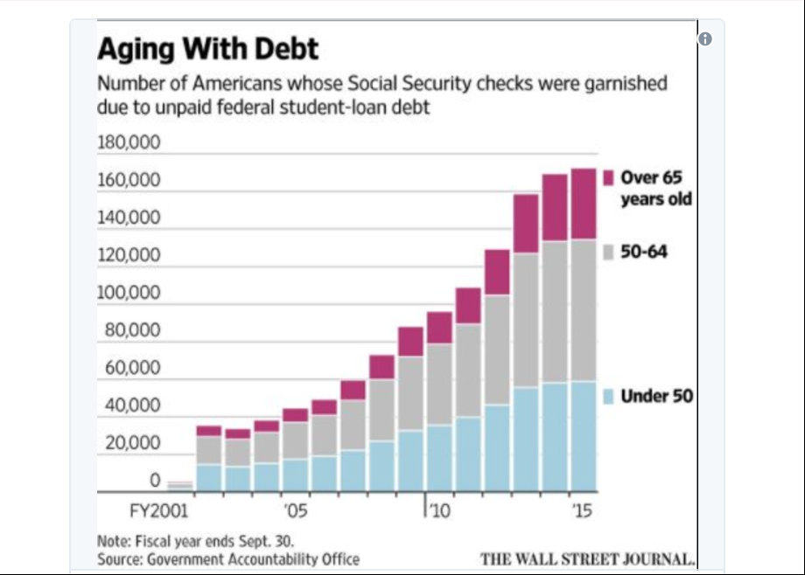
And their ranks are set to increase dramatically in the coming years: Roughly 7 million Americans age 50 and over owe $205 billion in federal student-loan debt — and 1 in 3 is in default.
While most of these retirees are paying off their own education debts, a good number were driven into debt by our contemporary crisis of college affordability, having taken out loans on behalf of their children.
The GAO report was produced at the request of Democratic senators Elizabeth Warren and Claire McCaskill. Warren has co-sponsored legislation that would exempt Social Security benefits from garnishment by the government. At present, a Social Security recipient can lose no more than 15 percent of his or her check to debt collection, but a cut of that size is more than enough to condemn many to financial desperation.
And while citizens who can prove themselves “totally and permanently disabled” can have their student debt erased, even those who fit that extreme classification often have their checks garnished, as they are unaware of their entitlement to debt forgiveness.
The overwhelming majority of America’s $1.3 trillion in student debt is held by those under 50. Which means that, barring reform, unpaid student debt is likely to claim a larger and larger share of retirees’ benefits in the coming decades.
Still, there are alternatives to providing relief for borrowers or higher benefits for Social Security recipients: We can always hope that, by the time the millennial generation is old enough to throw in the towel, their retirement crisis will have been averted by climate change, a global pandemic, or nuclear war.

2AC – GE Doesn’t Solve

It doesn’t help already-vicitimized students and biases technological schools
Alford 15 – Harry C. Alford, Co-founder, president and CEO of the National Black Chamber of Commerce. Contributor to The Hill, 2015 (“Obama administration is wrong on 'gainful employment'”, July 31st, Available Onlne at http://thehill.com/blogs/pundits-blog/education/249884-obama-administration-is-wrong-on-gainful-employment, Accessed 07-13-2017)
Recently, a chorus of critics of the for-profit education sector publicly began a written assault against those schools.
Like most of the recent criticism, it was flush with words like "predatory," "crushing debt" and "useless degrees." In attacking the for-profit sector of higher education, it also ignored the inconvenient facts about the tremendous benefit the sector provides, as well as the immense harm "gainful employment" will do to the very people the Obama administration purports to protect.
Unlike policymakers, the National Black Chamber of Commerce works directly with both students and employers. We see the value of for-profit schools at ground level. We see the difference they make in lives. We see the impact of skills training, flexible schedules, on-the-job training and marketable skills. We see how important this sector is to minority, low-income, nontraditional and other underserved students.
Given that perspective, it's hard to think of a set of rules that could do more harm to opportunity, or more enthusiastically allows attractive politics to divert educational purpose.
Let's take a breath, step back and look at the threat to a system that provides millions of students the best hope for educational opportunity and life enrichment they might otherwise never have.
According to the Association of Private Sector Colleges and Universities, 3,000 for-profit institutions serve 3.5 million students — students who are gaining educations, getting jobs, building lives. An estimated 50 percent of programs — for some providers, much higher — are projected to fail gainful employment standards that range from unrealistic to impossible.
What happens to the millions of students in these programs whose educational plans are disrupted; whose hopes of moving into careers are delayed or denied? Do they matter? Are they collateral damage? The Department of Education acknowledges that may be the case. It estimates that 32 percent of students in failing programs will have no "nearby transfer options." What are they to do? How do they now repay the student debt they are likely to have incurred to better their lives when they have no educational alternative?
Take a quick look at how the ratios derived by the policymakers stack up against the realities of the job market. To satisfy the gainful employment metric, a program has to show that the annual student loan payments are less than 8 percent of gross income, or less than 20 percent of discretionary income.
The argument usually stops there. But let's take it another step.
Those ratios apply beginning the first year after graduation, when most students are taking jobs to get a foot in the door. Now, suppose a student borrowed the maximum allowable federal loan of $57,500. That would mean — according to the gainful employment metric requirements — that he or she would have to start out earning at least $70,000 immediately after graduation.
Just for comparison, that is roughly the midpoint that the Bureau of Labor Statics says a first-year attorney can earn at a small- to mid-sized law firm. So in the curious logic of the regulations, a first-year graphic artist or line chef should make approximately what a lawyer makes after eight years of schooling. Does that even begin to make sense?
Furthermore, the Department of Education's own statistics show that the average student loan debt payment as a percentage of gross income is 16 percent for graduates of nonprofit institutions. Yet gainful employment sets the bar for measuring success at for-profit institutions as debt payments that are 8 percent or less of gross earnings. Such a blatant discrepancy is unfair and hypocritical. Were the gainful employment standards applied to nonprofit institutions (under the gainful employment regulations they are not), these schools would fail.

Their numbers are exaggerated
Leef 14 – George Leef, Policy Analyst at the John W. Pope Center for Higher Education Policy, a think tank that takes a critical view of higher education. He is also a free-lance writer for Forbes, 2014, (“Education Department's 'Gainful Employment' Rule: Futile Tinkering That Misses Root Problems”, November 21st, Avalable Online at https://www.forbes.com/sites/georgeleef/2014/11/21/education-departments-gainful-employment-rule-futile-tinkering-that-misses-root-problems/3/#400c1584fc92, Accessed 07-13-2017)
Secretary of Education Arne Duncan explained the theory behind the rule, saying, “Too many of these programs fail to provide students with the training they need while burying them in debt they cannot repay.” The trouble with that allegation is twofold.
First, the Department has no knowledge regarding the quality of the training students receive, but merely infers that if a substantial number of students aren’t finding jobs that pay well, it must be due to a failure of the school. But the training students need to get into the various occupations is quite standardized; if some students manage to find good work in the fields they’ve trained for while others don’t, we shouldn’t conclude that the school’s program was deficient.
Second, it isn’t the case that schools “bury” their students in debt. Students are not compelled to borrow for these programs, and many of those who do borrow are able to handle their repayments once they find steady employment.
And that brings us to the real problem, which is that there are now far too few opportunities for graduates of these career colleges—and indeed, all colleges and universities—to find the kind of full-time, entry-level jobs that used to be common for young Americans, college graduates or not.
The essence of the “student debt crisis” that this rule purports to solve has nothing to do with the cost or quality of career education. It has everything to do with the sharp decline in good, first-rung-on-the-ladder jobs for young people. As this recent New York Fed study shows, the labor market for young Americans is much worse than for older, experienced workers.
Furthermore, even when jobs are available, most are just part-time, owing to Obamacare’s employer mandate, a point that Dr. Scott Gottlieb makes in this Forbes article.
In short, the Department of Education intends to punish the weakest schools in the for-profit sector for the shambles the Obama administration has made of the job market for young people. According to Education Department estimates, if the rule were currently in place, about 1,400 programs would fail, affecting more than 800,000 students.

2AC – GE Studies Wrong

Data gaps and flaws disprove gainful employment effects
Miller and Libassi 17 – CJ Libassi, Policy Analyst on the Postsecondary Education team at American Progress. Libassi served as a research area specialist at the University of Michigan Education Policy Initiative; an English teaching assistant at a secondary school in Madrid, Spain, through the Fulbright Program; and an elementary school foreign-language teacher in the Prince George’s County Public Schools through Teach for America. He received his master of public policy from the University of Michigan Gerald R. Ford School of Public Policy, as well as a master of arts in teaching from American University and a B.A. in English, Spanish, and philosophy from the University of Scranton, Ben Miller, Senior Director for Postsecondary Education at American Progress. Previous research director for higher education at New America, as well as a senior policy advisor in the Office of Planning, Evaluation and Policy Development at the U.S. Department of Education. Miller’s work focuses on higher-education accountability, affordability, and financial aid, as well as for-profit colleges and other issues. Miller’s work has appeared in The New York Times, the Los Angeles Times, The Chronicle of Higher Education, and Inside Higher Ed, 2017 (“How Gainful Employment Reduces the Government’s Loan Forgiveness Costs”, June 8th, Available Online at https://www.americanprogress.org/issues/education/reports/2017/06/08/433531/gainful-employment-reduces-governments-loan-forgiveness-costs/, Accessed 07-11-2017)
Appendix A: Data limitations and methodology
Because of data limitations, there are several caveats about the analyses in this paper that are worth noting. First is the estimate of the debt and earnings levels of a typical graduate. Gainful employment calculations are based on circumstances for the typical graduate who received federal financial aid—their median debt relative to the higher of mean or median earnings. Those figures are calculated from separate distributions, one for earnings and one for debt. The result is that a borrower with earnings at the median may not have debt that falls at the median, or vice versa. It is therefore possible that graduates with typical earnings have atypical debt levels for their program. This could potentially bias the results in either direction. If borrowers with typical—e.g., mean or median—income typically have higher debt levels than the median loan level, then IDR may be relied on more heavily than anticipated. By contrast, if typical income borrowers have lower debt levels than the median loan level, then the average need for IDR may not be as great. Unfortunately, there is no way to know which programs are affected and in which direction.
Second, the earnings data also include individuals who received only federal grants—but no loans—for their programs. While this number is likely small at most private for-profit colleges—which produce all but a few of the nonpassing programs—it could affect the results. Graduates who did not borrow will drive down a program’s typical debt levels, potentially making its debt-to-earnings ratios look better than they really are for the subset of students who borrow. In addition, if nonborrowers have substantially higher incomes than borrowers, then they may make the debt-to-earnings ratios look artificially low for graduates who borrowed.
Third, the gainful employment regulations assume that every graduate is in a single-person household. IDR payments, however, assess an individual’s actual household size and therefore would include income from any other individuals in the household. This means that the gainful employment results may be biased upward or downward in some cases. If a borrower is in a multiperson household without additional income earners—such as a single parent with at least one child—then that borrower would pay even less on IDR than anticipated due to the higher income exemption that comes with a larger household size. By contrast, if a borrower’s household includes other income earners who do not have debt, then their overall earnings might be high enough to not need IDR.
Fourth, the loan amounts in the gainful employment metrics cap a graduate’s debt level at the cost of tuition, fees, books, and required supplies. This means that any borrowing for living expenses is not included in the calculation. As a result, the actual debt levels for graduates at some programs are higher than we can observe in the data. Greater debt levels also mean a graduate must earn a higher wage to avoid having a partial financial hardship and benefiting from IDR.
Finally, the debt figures include both federal and private loans. Although only the former are eligible for federal IDR programs, we believe that the volume of private loans should be quite small, and, given how far typical graduates at most nonpassing programs are from being able to afford their loan payments, would not affect our analysis very much. Additionally, given that loans for living expenses are not included in gainful employment data, any overestimate of the loan forgiveness amounts resulting from including private loan amounts is likely offset by the underestimate that results from excluding the federal borrowing students do above and beyond what they need for tuition, fees, and required expenses.

2AC – GE Bad – Career Programs

The bill creates an influx in career training programs that are substantially worse
Leef 14 – George Leef, Policy Analyst at the John W. Pope Center for Higher Education Policy, a think tank that takes a critical view of higher education. He is also a free-lance writer for Forbes, 2014, (“Education Department's 'Gainful Employment' Rule: Futile Tinkering That Misses Root Problems”, November 21st, Avalable Online at https://www.forbes.com/sites/georgeleef/2014/11/21/education-departments-gainful-employment-rule-futile-tinkering-that-misses-root-problems/3/#400c1584fc92, Accessed 07-13-2017)
Let us suppose that some or all of those programs eventually “fail” and thus lose eligibility for further government funds. Then what? Most of the students who would otherwise have attended them will enroll in one of the remaining career training programs (in some cases, a less convenient one, causing them added expense they can ill-afford).
If and when students complete their program, they might still encounter the same bad labor market conditions we have today. Unable to earn much, their high debt to income ratios will then imperil the schools they attended. Consequently, we’d see the steady whittling away of the for-profit sector, which might actually be the true point of this approach. As Professor Richard Vedder has written, “many of those pushing for stringent gainful employment rules believe that it is wrong or immoral to ‘profit’ from education.” Just so.
We are seeing this rule now for two reasons: the Obama administration is staffed with people hostile to for-profit business and the administration’s economic policies have made good jobs for young Americans so scarce.
The “gainful employment” rule won’t help students. It would (assuming that it ever goes into effect, which is doubtful) only reduce their options in training programs. This convoluted, arbitrary, Rube Goldbergesque regulation would accomplish nothing worthwhile.

2AC – GE Bad – Fine Arts

Gainful employment rules decimate fine-arts programs
Jerome 15 – Marc Jerome, Executive Vice President of Monroe College, a national leader in urban education that delivers some of the best outcomes for minority and low-income college students in the country. A seasoned educator and recognized thought-leader on the impact of gainful employment and other higher education regulations, Mr. Jerome served in the fall of 2013 on the U.S. Department of Education's Gainful Employment Negotiated Rulemaking Committee, 2015, (“Gainful Employment: An Unfair Rule With Bad Consequences”, November 6th, Available Online at https://www.jamesgmartin.center/2015/11/gainful-employment-an-unfair-rule-with-bad-consequences/, Accesssed 07-13-2-17)
Recently, the U.S. Department of Education unveiled its controversial College Scorecard website and accompanying data. This was the first time that student salary and debt information was made available on one page for the public to see and scrutinize. As expected, outcomes at some institutions were excellent while others were very poor.
The Scorecard is intended to prod institutions to take action to improve results for students. Imagine the outcry if, based on this first round of data, the Department penalized (or closed down) institutions whose outcomes were weak, without giving them a chance to make changes.
But that is what may happen in the upcoming year with the Department of Education’s Gainful Employment (GE) regulation. It judges degree programs on the debt and earnings of their graduates within just one area of higher education—the for-profit sector.
While the GE Rule may result in the closure of many poor-performing programs, this complex regulation will also harm many reputable ones by penalizing those that actually produce excellent outcomes for their students and imposing sanctions for poor performance without offering an opportunity to improve.
Let’s look at specific examples. The School of Visual Arts is a well-respected, highly competitive fine arts and design college in New York that happens to be for-profit. It has a high graduation rate (66 percent), a low student loan default rate (7 percent), and a low number of defaulters (59). These are exemplary outcomes, but because its graduates pursue creative and fine art careers that do not pay very much the first few years after graduation, many of its programs won’t pass the regulation.
In fact, Mark Schneider of College Measures, an expert in outcomes in higher education, analyzed debt and earnings information from the College Scorecard and concluded that virtually all programs at fine arts colleges in the country would fail the Rule. However, only for-profit programs like those at the School of Visual Arts would be penalized and ultimately shut down as a result. The non-profit schools get a free pass.
Another, much more personal example involves the institution where I work, Monroe College in the Bronx, NY.
Given the negative media attention surrounding for profit education, anyone watching the news might be surprised to know that there are for-profit institutions offering students better outcomes than our public or non-profit competitors. Monroe College is one of them.
Founded more than 80 years ago, we are a time-tested pioneer in educating minority and lower-income urban students, a segment of the population that has been largely underserved by post-secondary education institutions. Our campuses in the Bronx and New Rochelle provide focused, career-oriented, quality education to approximately 7,000 students each year.
Students choose Monroe because of our strong reputation and outcomes, which run counter to common misperceptions about the value of for-profit programs. Our graduation rate is in the top 5 percent of all degree-granting institutions in the United States whose student body is comprised of a majority of Pell recipients and according to U.S. News & World Report, we are the leading regional university for graduation rates that considerably exceed expectations based on student demographics.
Moreover, Monroe is a New York state leader in graduating African-American and Hispanic women with Associate degrees. We have an award-winning culinary program that competes for students almost exclusively with culinary programs at public and non-profit colleges, including some of the biggest names in culinary education.
That culinary program also competes with a culinary program at a regional non-profit college that is exempt from GE’s mandates. Looking broadly across all programs at the two colleges, Monroe has a 53 percent graduation rate, compared to 11 percent at the non-profit college. We also have a 5.7 percent student loan default rate, versus 17 percent at the non-profit college. Yet, if our program fails under GE, we would be required to post a warning notice to prospective students that, among other things, directs them to information on competing programs like the one where the outcomes clearly trail Monroe’s.
Here’s the irony: As the Department’s College Scorecard itself shows, the typical student at that college will finish the program with nearly $5,000 more in student debt and can expect to make less salary than those who went to Monroe’s program can.
Students comparing the two programs, however, won’t be given this critical information unless they seek it out themselves. Unlike Monroe, the other college would be under no obligation to proactively share program outcomes to prospective students. It makes no sense to refer a student to a program at another college with inferior outcomes just because that program is non-profit.

